**MINISTRY OF EDUCATION AND TRAINING**

**FPT UNIVERSITY**

Capstone Project Document

Website of Law Firm Management System

Report #4 – Software Design Specification

|  |  |
| --- | --- |
| Group 14 | |
| Group Members | Lê Duy Hoàng – Team Leader – SE60744  Đặng Nguyễn Khiêm – Team Member – SE60595  Trần Anh Tuấn – Team Member – SE60631  Phạm Văn Duy – Team Member – SE60634 |
| Supervisor | Nguyễn Văn Sang |
| Capstone Project code | LFMS |

- Ha Noi, 09/2014 –

Contents

## Design Overview

* This document describes the detailed design for both architectural and user interface design of the Law Firm Management System. It includes the architectural design and the detailed design of common functions and business functions. It also includes the design of database model. Each section in this report will describe a perspective of the system specifically.
* The architectural design describes the overall architecture of the system, and the architecture of each main component and subsystem. It will describe the patterns being used, the role of each component and the role of the system in the working environment, gives you an overview how the system is about to work.
* The detailed design describes static and dynamic structure for each component and function. It includes class diagrams, class explanations, and sequence diagrams of the main use cases.
* The database design describes the relationship between entities, and details of each entity.
* The user interface design describes the layout of the system, and some design for the screens.

## System Architectural Design

### Choice of System Architecture

#### System Architecture



Figure 4-1: System Architecture

* Database: This is the central data storage for the system.
* Management site: This is the website to manage Case, Customer, Staff, Service, Office.

#### MVC Architecture

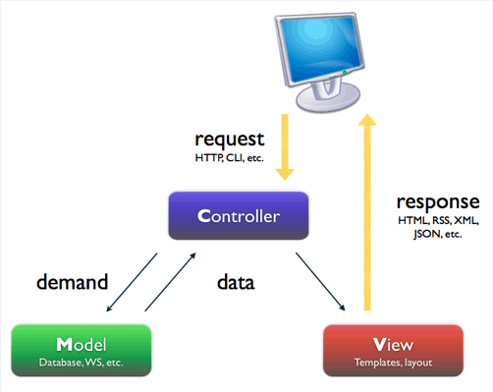

Figure 4-2: MVC Architecture

* Model: Functions that interact with the database or perform complex operations. In this architecture, model includes business logic and data access in one layer.
* View: The view displays the data and also takes input form user. It renders the model data into a form, such as graphics, buttons, and tables, and so on to display to the user.
* Controller: The controller handles all requests coming from the view or user interface. The data flows to whole application are controlled by controller.

### Discussion of Alternative Designs

### Description of System Interface

#### User Interfaces

UI should be simple, model and easy to use.

Support drag & drop easy for using Calendar Event.

#### Hardware Interfaces

The site should be deployed and available to a many devices can be use online.

* Server hardware: Support Windows hosting
* Client hardware: Can be desktop, laptop, smart phone, tablet,.. have internet connection

#### Software Interfaces

Run best on FireFox browser.

#### Communication Interfaces

The system using HTTP protocol to communicate between server and clients.

### Architectural Presentation

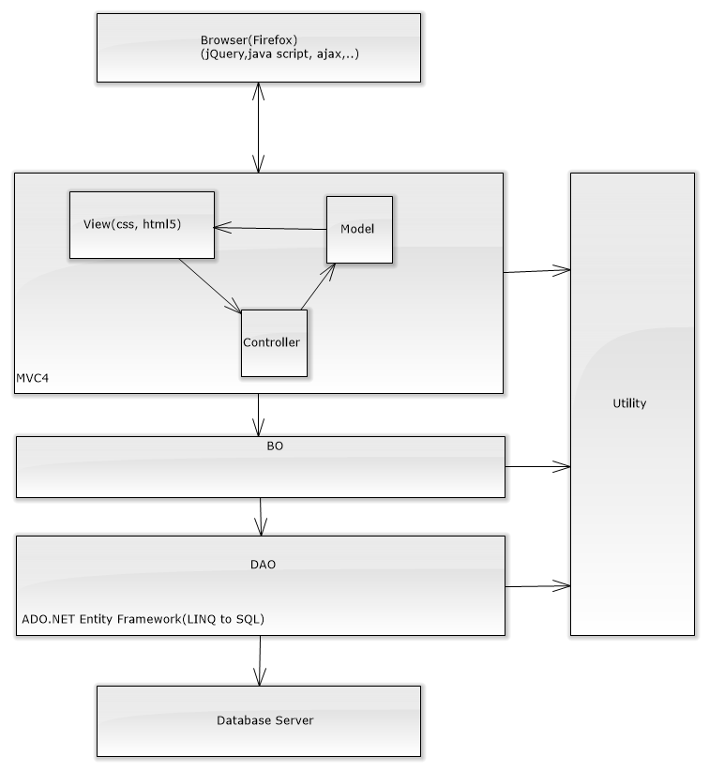

Figure 4-3: System overview

### Package Diagram

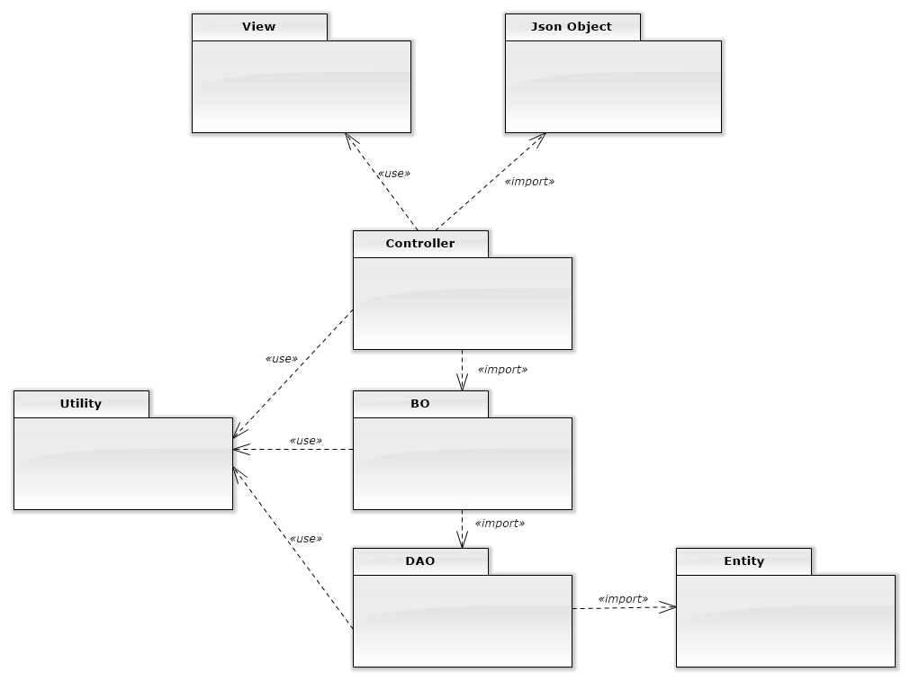

Figure 4-4: Package Diagram

## Detailed Design

### Data Model

#### Data Model Class Diagram

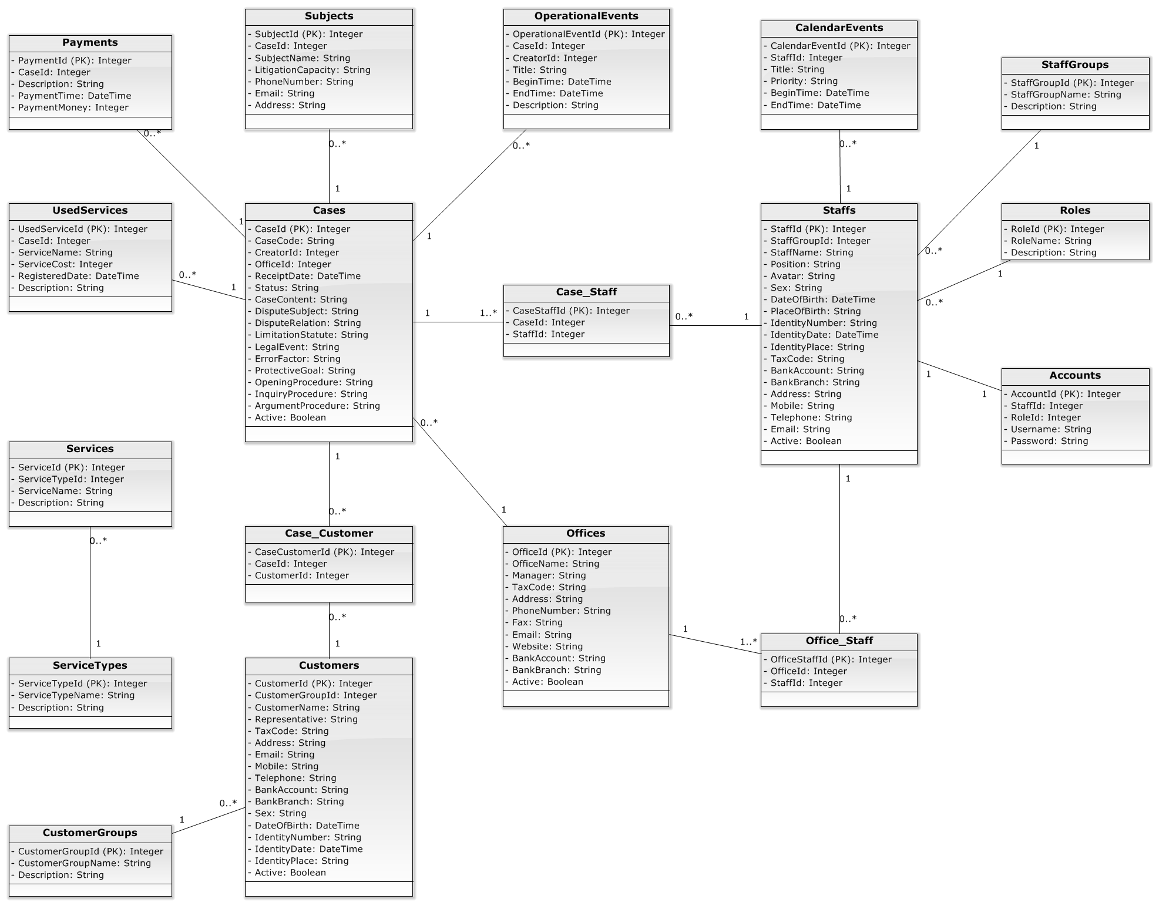

Figure 4-6: Data Model Class Diagram

### Controller

#### Controller Class Diagram

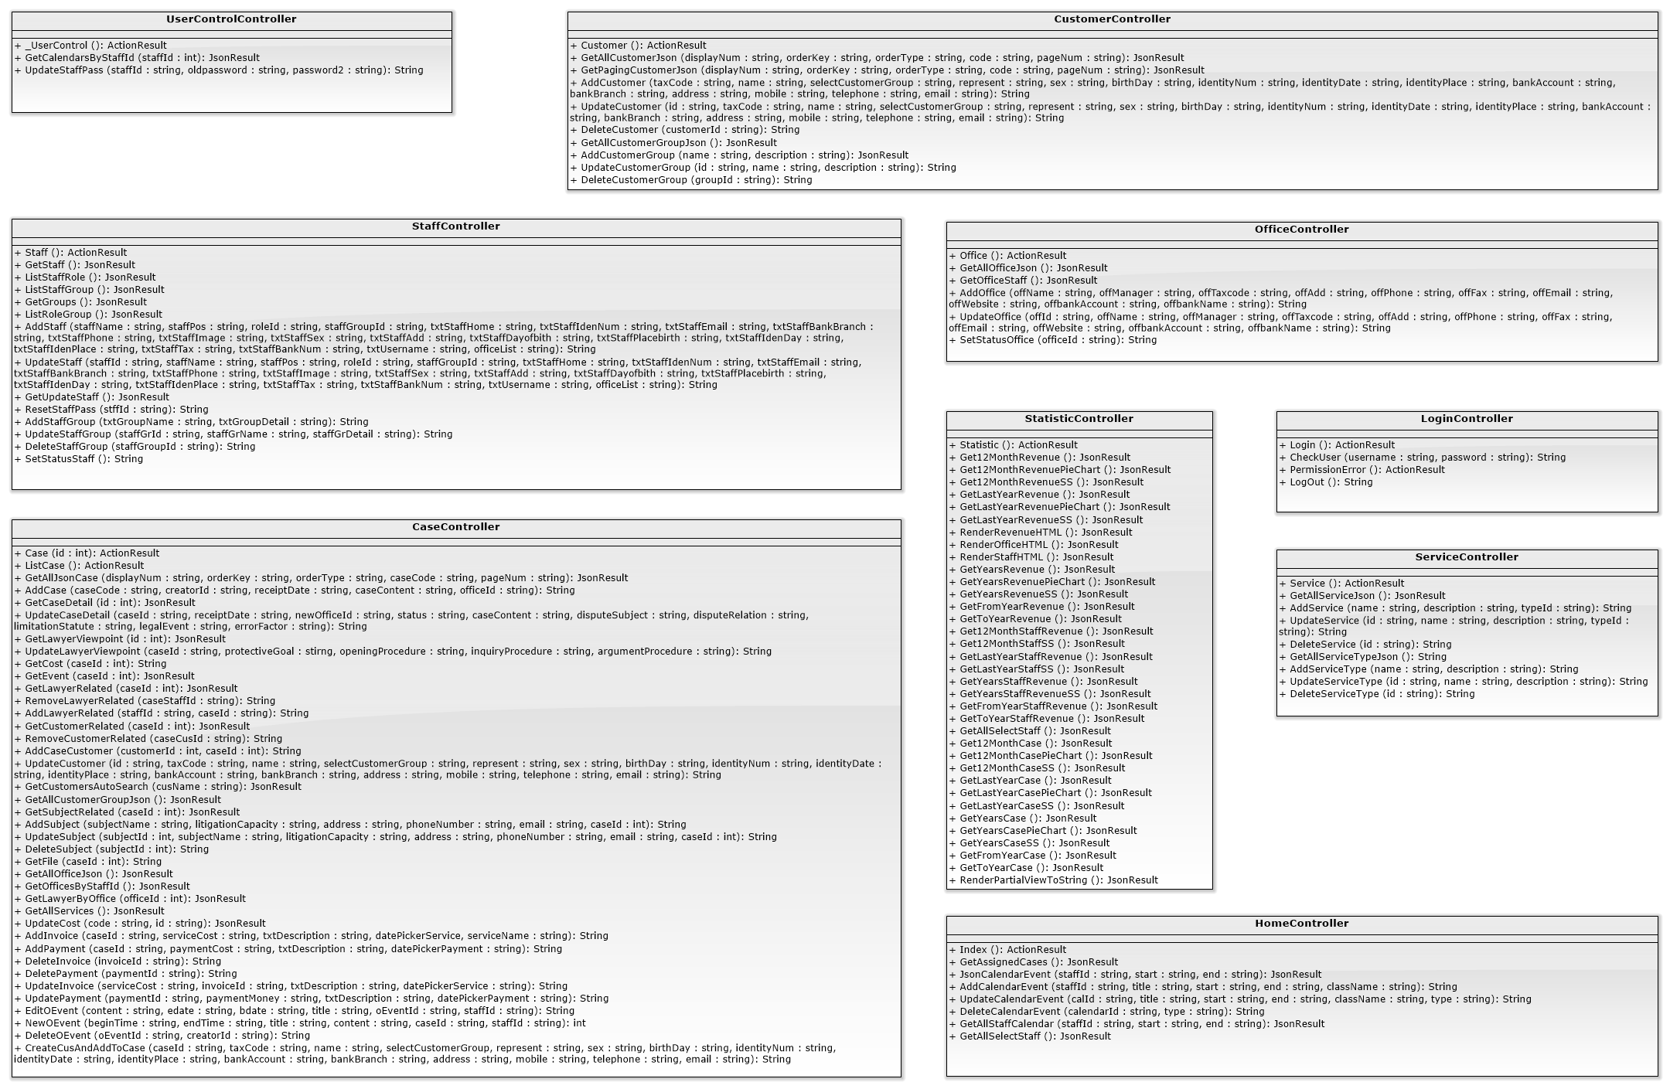

Figure 4-7: Controller Class Diagram

#### Controller Class Diagram Explanation

### Business

#### Business Logic Class Diagram

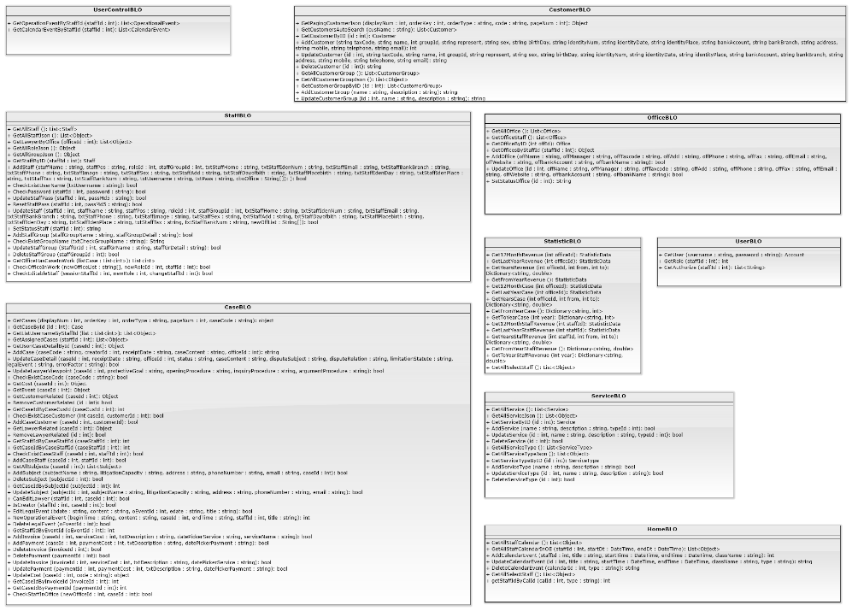

Figure 4-8: Business Class Diagram

#### Business Logic Class Diagram Explanation

##### CustomerBLO

|  |  |  |  |  |
| --- | --- | --- | --- | --- |
| Class | **CustomerBLO** | | | |
| **Description** | This method excute all action of customer which called from controller. | | | |
| **Base Class** | N/A | | | |
| **Constructor** | CustomerBLO | | | |
| **Prototype** | N/A | | | |
| **Source File** | CustomerBLO.cs | | | |
| **Namespace** | LFMS.Models.BLO | | | |
| **Attributes** | N/A | | | |
| **Methods** | **Name** | **Input** | **Output** | **Description** |
| GetPagingCustomerJson | int displayNum,  int orderKey,  string orderType,  string code,  int pageNum | Object | This method call method of customerDAO to get customer after paging and customer group |
| GetCustomersAutoSearch | string cusName | List<Customer> | This method call method of CustomerDAO to get customer in auto search |
| GetCustomerByID | int id | Customer | This method call method of CustomerDAO to get customer by id |
|  | AddCustomer | string taxCode,  string name,  int groupId,  string represent,  string sex,  string birthDay, string identityNum, string identityDate, string identityPlace, string bankAccount, string bankBranch, string address,  string mobile,  string telephone, string email | int | This method call method of CustomerDAO to add new customer |
|  | UpdateCustomer | int id,  string taxCode,  string name,  int groupId,  string represent,  string sex, string birthDay,  string identityNum, string identityDate, string identityPlace, string bankAccount, string bankBranch, string address,  string mobile,  string telephone,  string email | string | This method call method of CustomerDAO to update customer |
|  | DeleteCustomer | int id | string | This method call method of CustomerDAO to delete customer |
|  | GetAllCustomerGroup | N/A | List<CustomerGroup> | This method call method of CustomerDAO to get all customer group |
|  | GetAllCustomerGroupJson | N/A | List<Object> | This method call method of CustomerDAO to get all customer group by Json |
|  | GetCustomerGroupByID | int id | CustomerGroup | This method call method of CustomerDAO to get customer group by id |
|  | AddCustomerGroup | string name,  string description | string | This method call method of CustomerDAO to add new customer group |
|  | UpdateCustomerGroup | int Id,  string name,  string description | string | This method call CustomerDAO to UpdateCustomerGroup |
|  | DeleteCustomerGroup | int id | string | This method call method of CustomerDAO to delete customer group |

##### OfficeBLO

|  |  |  |  |  |
| --- | --- | --- | --- | --- |
| **Class** | **OfficeBLO** | | | |
| **Description** | This method excute all action of office which called from controller. | | | |
| **Base Class** | N/A | | | |
| **Constructor** | OfficeBLO | | | |
| **Prototype** | N/A | | | |
| **Source File** | OfficeBLO.cs | | | |
| **Namespace** | LFMS.Models.BLO | | | |
| **Attributes** | N/A | | | |
| **Methods** | **Name** | **Input** | **Output** | **Description** |
| GetAllOffice | N/A | List<Office> | This method call method of OfficeDAO to get all office |
| GetOfficeStaff | N/A | List<Office> | This method call method of OfficeDAO to get office staff |
| GetOfficeByID | int offId | Office | This method call method of OfficeDAO to get office by id |
|  | GetOfficesByStaffId | int staffId | Object | This method call method of OfficeDAO to get office by staff id |
|  | AddOffice | string offName, string offManager,  string offTaxcode,  string offAdd,  string offPhone, string offFax, string offEmail,  string offWebsite,  string offbankAccount, string offbankName | bool | This method call method of OfficeDAO to add office |
|  | UpdateOffice | int offId,  string offName,  string offManager,  string offTaxcode,  string offAdd, string offPhone,  string offFax,  string offEmail,  string offWebsite,  string offbankAccount, string offbankName | bool | This method call method of OfficeDAO to update office |
|  | SetStatusOffice | int offId | string | This method call method of OfficeDAO to set status office |

##### StaffBLO

|  |  |  |  |  |
| --- | --- | --- | --- | --- |
| **Class** | **StaffBLO** | | | |
| **Description** | This method excute all action of staff which called from controller. | | | |
| **Base Class** | N/A | | | |
| **Constructor** | staffBLO | | | |
| **Prototype** | N/A | | | |
| **Source File** | staffBLO.cs | | | |
| **Namespace** | LFMS.Models.BLO | | | |
| **Attributes** | N/A | | | |
| **Methods** | **Name** | **Input** | **Output** | **Description** |
| GetAllStaff | N/A | List<Staff> | This method call method of staffDAO to get all staff |
| GetAllStaffJson | N/A | List<Staff> | This method call method of staffDAO to get all staff by Json |
| GetLawyerByOffice | int officeId | List<Object> | This method call method of staffDAO to get lawyer by office |
|  | GetAllRoleJson | N/A | Object | This method call method of staffDAO to get all role by Json |
|  | GetAllGroupJson | N/A | Object | This method call method of staffDAO to get all group by Json |
|  | GetStaffByID | int staffId | Staff | This method call method of staffDAO to get staff by id |
|  | AddStaff | string staffName,  string staffPos,  int roleId, int staffGroupId,  string txtStaffHome,  string txtStaffIdenNum,  string txtStaffEmail,  string txtStaffBankBranch, string txtStaffPhone,  string txtStaffImage,  string txtStaffSex,  string txtStaffAdd,  string txtStaffDayofbith,  string txtStaffPlacebirth,  string txtStaffIdenDay,  string txtStaffIdenPlace,  string txtStaffTax,  string txtStaffBankNum,  string txtUsername,  int txtAppendantPeople,  string [] cboOffice | bool | This method call method of staffDAO to add new staff |
|  | CheckExistUserName | string txtUsername | bool | This method call method of staffDAO to check exist username |
|  | CheckPassword | int staffId, string password | bool | This method call method of staffDAO to check password |
|  | UpdateStaffPass | int staffId,  string password2 | bool | This method call method of staffDAO to update staff pass |
|  | ResetStaffPass | int staffId | bool | This method call method of staffDAO to reset staff pass |
|  | UpdateStaff | int staffId,  string staffName,  string staffPos,  int roleId, int staffGroupId,  string txtStaffHome, string txtStaffIdenNum,  string txtStaffEmail,  string txtStaffBankBranch, string txtStaffPhone,  string txtStaffImage,  string txtStaffSex,  string txtStaffAdd,  string txtStaffDayofbith,  string txtStaffPlacebirth,  string txtStaffIdenDay,  string txtStaffIdenPlace,  string txtStaffTax,  string txtStaffBankNum, int detailAppendantPeople, String [] newOffList | bool | This method call method of staffDAO to update staff |
|  | SetStatusStaff | int staffId | string | This method call method of staffDAO to set status staff |
|  | AddStaffGroup | string staffGroupName,  string staffGroupDetail,  double txtBaseSalary | bool | This method call method of staffDAO to add staff group |
|  | CheckExistGroupName | string txtCheckGroupName | bool | This method call method of staffDAO to check exist group name |
|  | UpdateStaffGroup | int StaffGrId,  string staffGrName,  string staffGrDetail, string txtEditMoney | bool | This method call method of staffDAO to update staff group |
|  | DeleteStaffGroup | int staffGroupId | bool | This method call method of staffDAO to delete staff group |
|  | GetOfficeHasCaseInWork | List<int> listCase | List<int> | This method call method of staffDAO to get office has case in work |
|  | CheckOfficeInWork | String[] newOfficeList,  int newRoleId,  int staffId | bool | This method call method of staffDAO to check office in work |
|  | CheckEditableStaff | int sessionStaffId,  int newRole, int changeStaffId | bool | This method call method of staffDAO to check editable staff |

##### CaseBLO

|  |  |  |  |  |
| --- | --- | --- | --- | --- |
| **Class** | **CaseBLO** | | | |
| **Description** | This method excute all action of case which called from controller. | | | |
| **Base Class** | N/A | | | |
| **Constructor** | CaseBLO | | | |
| **Prototype** | N/A | | | |
| **Source File** | caseBLO.cs | | | |
| **Namespace** | LFMS.Models.BLO | | | |
| **Attributes** | N/A | | | |
| **Methods** | **Name** | **Input** | **Output** | **Description** |
| GetCases | int displayNum,  int orderKey,  string orderType, int pageNum,  string caseCode, List<String> author | object | This method call method of caseDAO to get all case |
| GetCaseById | int id | Case | This method call method of caseDAO to get case by Id |
| GetListUsernameByStaffId | List<int> list | List<Object> | This method call method of caseDAO to get list uername by staff id |
|  | GetAssignedCases | int staffId | List<Object> | This method call method of caseDAO to get assigned cases |
|  | GetJsonCaseDetailById | int caseId | Object | This method call method of caseDAO to get Json case detail by Id |
|  | AddCase | string caseCode,  int creatorId,  string receiptDate,  string caseContent,  int officeId | string | This method call method of caseDAO to add new case |
|  | UpdateCaseDetail | int caseId,  string receiptDate,  int officeId,  string status,  string caseContent,  string disputeSubject,  string disputeRelation,  string limitationStatute,  string legalEvent,  string errorFactor | bool | This method call method of caseDAO to update case detail |
|  | UpdateLawyerViewpoint | int caseId,  string protectiveGoal,  string openingProcedure,  string inquiryProcedure,  string argumentProcedure | bool | This method call method of caseDAO to update lawyer view point |
|  | CheckExistCaseCode | string caseCode | bool | This method call method of caseDAO to check exist case code |
|  | GetCost | int caseId | Object | This method call method of caseDAO to get cost |
|  | GetEvent | int caseId | Object | This method call method of caseDAO to get new event |
|  | GetCustomerRelated | int caseId | Object | This method call method of caseDAO to get customer related |
|  | RemoveCustomerRelated | int id | bool | This method call method of caseDAO to remove customer related |
|  | GetCaseIdByCaseCusId | int caseCusId | int | This method call method of caseDAO to get case Id by customer Id |
|  | CheckExistCaseCustomer | int caseId,  int customerId | bool | This method call method of caseDAO to check exist case customer |
|  | AddCaseCustomer | int caseId,  int customerId | bool | This method call method of caseDAO to add a new case of customer |
|  | GetLawyerRelated | int caseId | Object | This method call method of caseDAO to get lawyer related |
|  | RemoveLawyerRelated | int id | bool | This method call method of caseDAO to remove lawyer related |
|  | GetStaffIdByCaseStaffId | int caseStaffId | int | This method call method of caseDAO to get staff id by case staff id |
|  | GetCaseIdByCaseStaffId | int caseStaffId | int | This method call method of caseDAO to get case id by case staff id |
|  | CheckExistCaseStaff | int caseId,  int staffId | bool | This method call method of caseDAO to check exist case staff |
|  | AddCaseStaff | int caseId,  int staffId | bool | This method call method of caseDAO to add a new case of staff |
|  | GetAllSubjects | int caseId | List<Subject> | This method call method of caseDAO to get all subjects |
|  | AddSubject | string subjectName,  string litigationCapacity,  string address,  string phoneNumber,  string email,  int caseId | bool | This method call method of caseDAO to add new subject |
|  | DeleteSubject | int subjectId | bool | This method call method of caseDAO to delete subject |
|  | GetCaseIdBySubjectId | int subjectId | int | This method call method of caseDAO to get case id by subject id |
|  | UpdateSubject | int subjectId,  string subjectName,  string litigationCapacity,  string address,  string phoneNumber,  string email | bool | This method call method of caseDAO to update subject |
|  | CanEditLawyer | int staffId,  int caseId | bool | This method call method of caseDAO to check can edit lawyer |
|  | IsCreator | int staffId,  int caseId | bool | This method call method of caseDAO to check who creator |
|  | EditLegalEvent | string bdate,  string content,  int oEventId,  string edate,  string title | bool | This method call method of caseDAO to edit legal event |
|  | NewOperationalEvent | string beginTime,  string content,  int caseId,  string endTime,  int staffId,  string title | int | This method call method of caseDAO to check new operational event |
|  | DeleteLegalEvent | int oEventId | bool | This method call method of caseDAO to delete legal event |
|  | GetStaffIdByEventId | int oEventId | int | This method call method of caseDAO to get staff id by event id |
|  | AddInvoice | int caseId,  int serviceCost,  string txtDescription,  string datePickerService,  string serviceName | bool | This method call method of caseDAO to add new invoice |
|  | AddPayment | int caseId,  int paymentCost,  string txtDescription,  string datePickerPayment | bool | This method call method of caseDAO to add new payment |
|  | DeleteInvoice | int invoiceId | bool | This method call method of caseDAO to delete invoice |
|  | DeletePayment | int paymentId | bool | This method call method of caseDAO to delete payment |
|  | UpdateInvoice | int invoiceId,  int serviceCost,  string txtDescription,  string datePickerService | bool | This method call method of caseDAO to update invoice |
|  | UpdatePayment | int paymentId,  int paymentCost,  string txtDescription,  string datePickerPayment | bool | This method call method of caseDAO to update payment |
|  | UpdateCost | int caseId,  string code | object | This method call method of caseDAO to update cost |
|  | GetCaseIdByInvoiceId | int invoiceId | int | This method call method of caseDAO to get case id by invoice id |
|  | GetCaseIdByPaymentId | int paymentId | int | This method call method of caseDAO to get case id by payment id |
|  | CheckStaffInOffice | int newOfficeId,  int caseId | bool | This method call method of caseDAO to check staff in office |

##### StatisticBLO

|  |  |  |  |  |
| --- | --- | --- | --- | --- |
| **Class** | **StatisticBLO** | | | |
| **Description** | This method excute all action of statistic which called from controller. | | | |
| **Base Class** | N/A | | | |
| **Constructor** | StatisticBLO | | | |
| **Prototype** | N/A | | | |
| **Source File** | StatisticBLO.cs | | | |
| **Namespace** | LFMS.Models.BLO | | | |
| **Attributes** | N/A | | | |
| **Methods** | **Name** | **Input** | **Output** | **Description** |
| Get12MonthRevenue | int officeId | StatisticData | This method call method of statisticDAO to get 12 month of revenue |
| GetLastYearRevenue | int officeId | StatisticData | This method call method of statisticDAO to get last year revenue |
| GetYearsRevenue | int officeId,  int from,  int to | Dictionary<string, double> | This method call method of statisticDAO to get years revenue |
|  | GetFromYearRevenue | N/A | Dictionary<string, int> | This method call method of statisticDAO to get from year revenue |
|  | Get12MonthCase | int officeId | StatisticData | This method call method of statisticDAO to get 12 month of case |
|  | GetLastYearCase | int officeId | StatisticData | This method call method of statisticDAO to get last year case |
|  | GetYearsCase | int officeId,  int from,  int to | Dictionary<string, double> | This method call method of statisticDAO to get year case |
|  | GetFromYearCase | N/A | Dictionary<string, int> | This method call method of statisticDAO to from year case |
|  | GetToYearCase | int year | Dictionary<string, int> | This method call method of statisticDAO to get to year case |
|  | Get12MonthStaffRevenue | int staffId | StatisticData | This method call method of statisticDAO to get 12 month staff revenue |
|  | GetLastYearStaffRevenue | int staffId | StatisticData | This method call method of statisticDAO to get last year staff revenue |
|  | GetYearsStaffRevenue | int staffId,  int from,  int to | Dictionary<string, double> | This method call method of statisticDAO to get year staff revenue |
|  | GetFromYearStaffRevenue | N/A | Dictionary<string, int> | This method call method of statisticDAO to get from year staff revenue |
|  | GetToYearStaffRevenue | int year | Dictionary<string, int> | This method call method of statisticDAO to get to year staff revenue |
|  | GetAllSelectStaff | N/A | List<Object> | This method call method of statisticDAO to get all selected staff |

##### UserBLO

|  |  |  |  |  |
| --- | --- | --- | --- | --- |
| **Class** | **UserBLO** | | | |
| **Description** | This method excute all action of uer which called from controller. | | | |
| **Base Class** | N/A | | | |
| **Constructor** | UserBLO | | | |
| **Prototype** | N/A | | | |
| **Source File** | UserBLO.cs | | | |
| **Namespace** | LFMS.Models.BLO | | | |
| **Attributes** | N/A | | | |
| **Methods** | **Name** | **Input** | **Output** | **Description** |
| GetUser | string username,  string password | Account | This method call method of userDAO to get user |
| GetRole | int staffId | List<String> | This method call method of userDAO to get role of user |
| GetAuthorize | int staffId | int | This method call method of userDAO to get authorize of user |

##### HomeBLO

|  |  |  |  |  |
| --- | --- | --- | --- | --- |
| **Class** | **HomeBLO** | | | |
| **Description** | This method excute all action of home which called from controller. | | | |
| **Base Class** | N/A | | | |
| **Constructor** | HomeBLO | | | |
| **Prototype** | N/A | | | |
| **Source File** | HomeBLO.cs | | | |
| **Namespace** | LFMS.Models.BLO | | | |
| **Attributes** | N/A | | | |
| **Methods** | **Name** | **Input** | **Output** | **Description** |
| GetAllStaffCalendar | int staffId,  string start,  string end | List<Object> | This method call method of homeDAO to get all calendar of staff |
| GetAllStaffCalendarInOE | int staffId,  string start,  string end | List<Object> | This method call method of homeDAO to get all calendar of staff by time |
| AddCalendarEvent | int staffId,  string title,  string start,  string end,  string className | int | This method call method of homeDAO to add new calendar event |
|  | UpdateCalendarEvent | int Id,  string title,  string start,  string end,  string className,  string type | string | This method call method of homeDAO to update calendar event |
|  | DeleteCalendarEvent | int calendarId,  string type | string | This method call method of homeDAO to delete calendar event |
|  | GetAllSelectStaff | int staffId | List<Object> | This method call method of homeDAO to get all selected staff |
|  | getStaffIdByCalId | int calId, string type | int | This method call method of homeDAO to get calendar of staff by calendar id |

##### ServiceBLO

|  |  |  |  |  |
| --- | --- | --- | --- | --- |
| **Class** | **ServiceBLO** | | | |
| **Description** | This method excute all action of service which called from controller. | | | |
| **Base Class** | N/A | | | |
| **Constructor** | ServiceBLO | | | |
| **Prototype** | N/A | | | |
| **Source File** | ServiceBLO.cs | | | |
| **Namespace** | LFMS.Models.BLO | | | |
| **Attributes** | N/A | | | |
| **Methods** | **Name** | **Input** | **Output** | **Description** |
| GetAllService | N/A | List<Service> | This method call method of serviceDAO to get all service |
| GetAllServiceJson | N/A | List<Object> | This method call method of serviceDAO to get all service by Json |
| GetServiceByID | int id | Service | This method call method of serviceDAO to get all service by Id |
|  | AddService | string name,  string description,  int typeId | string | This method call method of serviceDAO to add new service |
|  | UpdateService | int id,  string name,  string description,  int typeId | string | This method call method of serviceDAO to update service |
|  | DeleteService | int id | string | This method call method of serviceDAO to delete service |
|  | GetAllServiceType | N/A | List<ServiceType> | This method call method of serviceDAO to get all type of service |
|  | GetAllServiceTypeJson | N/A | List<Object> | This method call method of serviceDAO to get all type of service by Json |
|  | GetServiceTypeByID | int id | ServiceType | This method call method of serviceDAO to get all type of service by Id |
|  | AddServiceType | string name,  string description | string | This method call method of serviceDAO to add new service type |
|  | UpdateServiceType | int id,  string name,  string description | string | This method call method of serviceDAO to update service type |
|  | DeleteServiceType | int id | string | This method call method of serviceDAO to delete service type |

##### UserControlBLO

|  |  |  |  |  |
| --- | --- | --- | --- | --- |
| **Class** | **UserControlBLO** | | | |
| **Description** | This method excute all action of user control which called from controller. | | | |
| **Base Class** | N/A | | | |
| **Constructor** | UserControlBLO | | | |
| **Prototype** | N/A | | | |
| **Source File** | UserControlBLO.cs | | | |
| **Namespace** | LFMS.Models.BLO | | | |
| **Attributes** | N/A | | | |
| **Methods** | **Name** | **Input** | **Output** | **Description** |
| GetOperationEventByStaffId | int staffId | List<OperationalEvent> | This method call method of userControlDAO to get operation event by staff id |
| GetCalendarEventByStaffId | int staffId | List<CalendarEvent> | This method call method of userControlDAO to get calendar event by staff id |

### Data Access

#### Data Access Class Diagram

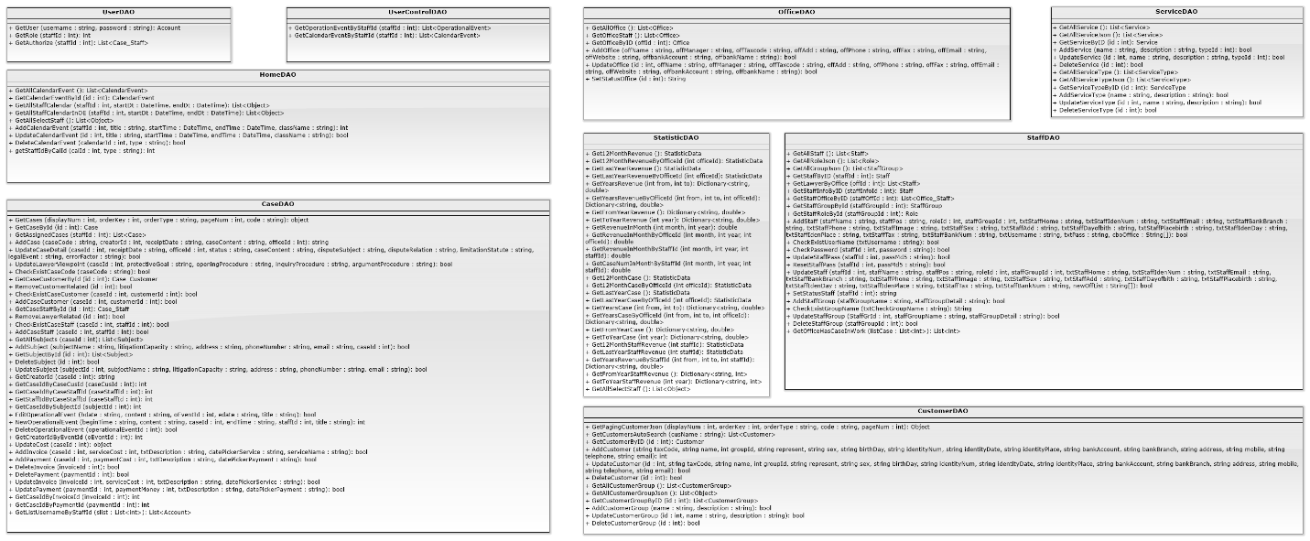

Figure 4-9: Data Access Class Diagram

#### Data Access Class Diagram Explanation

##### UserDAO

|  |  |  |  |  |
| --- | --- | --- | --- | --- |
| **Class** | **UserDAO** | | | |
| **Description** | This class excute all authorization to database. | | | |
| **Base Class** | N/A | | | |
| **Constructor** | UserDAO | | | |
| **Prototype** | N/A | | | |
| **Source File** | UserDAO.cs | | | |
| **Namespace** | LFMS.Models.DAO | | | |
| **Attributes** | N/A | | | |
| **Methods** | **Name** | **Input** | **Output** | **Description** |
| GetUser | string username, string password | Account | Get account from database to check in login. |
| GetRole | int staffId | int | Get role of staff from database |
| GetAuthorize | int staffId | List<Case_Staff> | Get all id of case of staff to check Authorize from database |

##### .UserControlDAO

|  |  |  |  |  |
| --- | --- | --- | --- | --- |
| **Class** | UserControlDAO | | | |
| **Description** | This class excute to get notification of staff about event and calendar from database. | | | |
| **Base Class** | N/A | | | |
| **Constructor** | UserControlDAO | | | |
| **Prototype** | N/A | | | |
| **Source File** | UserControlDAO.cs | | | |
| **Namespace** | LFMS.Models.DAO | | | |
| **Attributes** | N/A | | | |
| **Methods** | **Name** | **Input** | **Output** | **Description** |
| GetOperationEventByStaffId | int staffId | List<OperationalEvent> | System excute to get operation event by staff id from database. |
| GetCalendarEventByStaffId | int staffId | int | System excute to get calendar event by staff id from database |

##### OfficeDAO

|  |  |  |  |  |
| --- | --- | --- | --- | --- |
| **Class** | **OfficeDAO** | | | |
| **Description** | This class excute all action of office to database. | | | |
| **Base Class** | N/A | | | |
| **Constructor** | OfficeDAO | | | |
| **Prototype** | N/A | | | |
| **Source File** | OfficeDAO.cs | | | |
| **Namespace** | LFMS.Models.DAO | | | |
| **Attributes** | N/A | | | |
| **Methods** | **Name** | **Input** | **Output** | **Description** |
| GetActiveOffice | N/A | List<Office> | System excute to get all active office from database |
| GetRole | N/A | List<Office> | System excute to get all office from database. |
| GetOfficeStaff | N/A | List<Office> | System excute to get all active office from database. |
|  | GetOfficeByID | int offId | Office | System excute to get office by office id from database. |
|  | AddOffice | string offName,  string offManager, string offTaxcode, string offAdd, string offPhone,  string offFax,  string offEmail,  string offWebsite, string offbankAccount, string offbankName | bool | System excute to add new office to database. |
|  | UpdateOffice | int offId,  string offName,  string offManager, string offTaxcode, string offAdd, string offPhone,  string offFax,  string offEmail,  string offWebsite,  string offbankAccount, string offbankName | bool | System excute to update an office to database. |
|  | SetStatusOffice | int id | String | System excute to set the active of office to database. |
|  | CheckExistOfficeName | string txtOfficename | bool | System excute to check the name of office of office from database. |

##### ServiceDAO

|  |  |  |  |  |
| --- | --- | --- | --- | --- |
| **Class** | **ServiceDAO** | | | |
| **Description** | This class excute all action of service to database. | | | |
| **Base Class** | N/A | | | |
| **Constructor** | ServiceDAO | | | |
| **Prototype** | N/A | | | |
| **Source File** | ServiceDAO.cs | | | |
| **Namespace** | LFMS.Models.DAO | | | |
| **Attributes** | N/A | | | |
| **Methods** | **Name** | **Input** | **Output** | **Description** |
| GetAllService | N/A | List<Service> | System excute to get all service from database. |
| GetAllServiceJson | N/A | List<Object> | System excute to get all service type from database. |
| GetServiceByID | int id | Service | System excute to get service by id from database. |
|  | AddService | string name,  string description, int typeId | bool | System excute to add new service to database. |
|  | UpdateService | int id,  string name,  string description, int typeId | bool | System excute to update an service to database. |
|  | DeleteService | int id | bool | System excute to delete a service to database. |
|  | GetAllServiceType | N/A | List<ServiceType> | System excute to get all service type from database. |
|  | GetAllServiceTypeJson | N/A | List<Object> | System excute to get all service from database. |
|  | GetServiceTypeByID | int id | ServiceType | System excute to get service type by id from database. |
|  | AddServiceType | string name,  string description | bool | System excute to add new service type to database. |
|  | UpdateServiceType | int id,  string name, string description | bool | System excute to update a service type to database. |
|  | DeleteServiceType | int id | bool | System excute to delete a service type to database. |

##### HomeDAO

|  |  |  |  |  |
| --- | --- | --- | --- | --- |
| **Class** | **HomeDAO** | | | |
| **Description** | This class excute all action in Home view to database. | | | |
| **Base Class** | N/A | | | |
| **Constructor** | HomeDAO | | | |
| **Prototype** | N/A | | | |
| **Source File** | HomeDAO.cs | | | |
| **Namespace** | LFMS.Models.DAO | | | |
| **Attributes** | N/A | | | |
| **Methods** | **Name** | **Input** | **Output** | **Description** |
| GetAllCalendarEvent | N/A | List<CalendarEvent> | System excute to get all calendar event from database |
| GetCalendarEventById | int id | CalendarEvent | System excute to get calendar event by id from database. |
| GetAllStaffCalendar | int staffId, DateTime startDt, DateTime endDt | List<Object> | System excute to get calendar event of staff by staff id from database. |
|  | GetAllStaffCalendarInOE | int staffId, DateTime startDt, DateTime endDt | List<Object> | System excute to get operation event of staff by staff id from database. |
|  | GetAllSelectStaff | int staffId | List<Object> | System excute to get account and password from database. |
|  | AddCalendarEvent | int staffId,  string title, DateTime startTime, DateTime endTime, string className | int | System excute to add new a calendar event to database. |
|  | UpdateCalendarEvent | int id,  string title, DateTime startTime, DateTime endTime, string className, string type | bool | System excute to update a calendar or operation event to database. |
|  | DeleteCalendarEvent | int calendarId,  string type | bool | System excute to delete a calendar or anoperation event to database. |
|  | getStaffIdByCalId | int calId,  string type | int | System excute to get calendar or operation event by calendar id from database. |

##### CaseDAO

|  |  |  |  |  |
| --- | --- | --- | --- | --- |
| **Class** | **CaseDAO** | | | |
| **Description** | This class excute all action of Case to database. | | | |
| **Base Class** | N/A | | | |
| **Constructor** | CaseDAO | | | |
| **Prototype** | N/A | | | |
| **Source File** | CaseDAO.cs | | | |
| **Namespace** | LFMS.Models.DAO | | | |
| **Attributes** | N/A | | | |
| **Methods** | **Name** | **Input** | **Output** | **Description** |
| GetCases | int displayNum, int orderKey,  string orderType,  int pageNum,  string code, List<String> author | object | System excute to get all case after sort from database. |
| GetCaseById | int id | Case | System excute to get case by case id from database. |
| GetAssignedCases | int staffId | List<Case> | System excute to get all case of staff y staff id from database. |
|  | AddCase | string caseCode,  int creatorId,  string receiptDate, string caseContent, int officeId | string | System excute to add new a case to database. |
|  | UpdateCaseDetail | int caseId,  string receiptDate,  int officeId,  string status,  string caseContent, string disputeSubject, string disputeRelation, string limitationStatute, string legalEvent, string errorFactor | bool | System excute to update a case to database. |
|  | DeleteService | int id | bool | System excute to delete a service to database. |
|  | UpdateLawyerViewpoint | int caseId,  string protectiveGoal, string openingProcedure, string inquiryProcedure, string argumentProcedure | bool | System excute to update view point of lawyer to database. |
|  | CheckExistCaseCode | string caseCode | bool | System excute to check exist casecode from database. |
|  | GetCaseByCaseCode | string caseCode | Case | System excute to get case by casecode from database. |
|  | GetCaseCustomerById | int id | Case_Customer | System excute to get case of customer from database. |
|  | RemoveCustomerRelated | int id | bool | System excute to remove customer from a case to database. |
|  | CheckExistCaseCustomer | int caseId, int customerId | bool | System excute to check exist customer of case from database. |
|  | AddCaseCustomer | int caseId, int customerId | bool | System excute to add new casecustomer to database. |
|  | GetCaseStaffById | int id | Case_Staff | System excute to get casestaff from database. |
|  | RemoveLawyerRelated | int id | bool | System excute to remove lawyer from case to database |
|  | CheckExistCaseStaff | int caseId,  int staffId | bool | System excute to check exist case staff from database |
|  | AddCaseStaff | int caseId,  int staffId | bool | System excute to add new a case staff to database |
|  | GetAllSubjects | int caseId | List<Subject> | System excute to get all subjects of case from database. |
|  | AddSubject | string subjectName,  string litigationCapacity, string address,  string phoneNumber,  string email,  int caseId | bool | System excute to add new a subjects of case to database. |
|  | GetSubjectById | int id | Subject | System excute to get subjects by subject id from database |
|  | DeleteSubject | int id | bool | System excute to remove a subject to database. |
|  | UpdateSubject | int subjectId,  string subjectName,  string litigationCapacity, string address,  string phoneNumber,  string email | bool | System excute to update a subject to database. |
|  | GetCreatorId | int caseId | string | System excute to get creator id of case from database |
|  | GetCaseIdByCaseCusId | int caseCusId | int | System excute to get case id of case by case customer id from database |
|  | GetCaseIdByCaseStaffId | int caseStaffId | int | System excute to get case id of case by case staff id from database |
|  | GetStaffIdByCaseStaffId | int caseStaffId | Int | System excute to get staff id of case by case staff id from database |
|  | GetCaseIdBySubjectId | int subjectId | int | System excute to get case id of case by subject id from database |
|  | EditOperationalEvent | string bdate,  string content,  int oEventId,  string edate,  string title | bool | System excute to edit operation event of case to database |
|  | NewOperationalEvent | string beginTime,  string content,  int caseId,  string endTime,  int staffId,  string title | int | System excute to add new operation event of case to database |
|  | DeleteOperationalEvent | int operationalEventId | bool | System excute to delete operation event of case to database |
|  | GetCreatorIdByEventId | int oEventId | int | System excute to get creator id by operation id from database |
|  | UpdateCost | int caseId | object | System excute to update cost of case to database. |
|  | AddInvoice | int caseId,  int serviceCost,  string txtDescription,  string datePickerService, string serviceName | bool | System excute to new invoice of case to database. |
|  | AddPayment | int caseId,  int paymentCost,  string txtDescription,  string datePickerPayment | bool | System excute to add new payment of case to database. |
|  | DeleteInvoice | int invoiceId | bool | System excute to delete invoice of case to database. |
|  | DeletePayment | int paymentId | bool | System excute to delete payment of case to database. |
|  | UpdateInvoice | int invoiceId,  int serviceCost,  string txtDescription,  string datePickerService | bool | System excute to update invoice of case to database. |
|  | UpdatePayment | int paymentId,  int paymentMoney,  string txtDescription,  string datePickerPayment | bool | System excute to update payment of case to database. |
|  | GetCaseIdByInvoiceId | int invoiceId | int | System excute to get case id by invoice id from database. |
|  | GetCaseIdByPaymentId | int paymentId | int | System excute to get case id by payment id from database. |
|  | GetListUsernameByStaffId | List<int> slist | List<Account> | System excute to get list username of staff by list of staff id from database. |

##### StaffDAO

|  |  |  |  |  |
| --- | --- | --- | --- | --- |
| **Class** | **StaffDAO** | | | |
| **Description** | This class excute all action of Staff to database. | | | |
| **Base Class** | N/A | | | |
| **Constructor** | StaffDAO | | | |
| **Prototype** | N/A | | | |
| **Source File** | StaffDAO.cs | | | |
| **Namespace** | LFMS.Models.DAO | | | |
| **Attributes** | N/A | | | |
| **Methods** | **Name** | **Input** | **Output** | **Description** |
| GetAllStaff | N/A | List<Staff> | System excute to get all staff from database. |
| GetAllRoleJson | N/A | List<Role> | System excute to get all role from database. |
| GetAllGroupJson | N/A | List<StaffGroup> | System excute to get all group of staff from database. |
|  | GetStaffByID | int staffId | Staff | System excute to get staff by staff id from database. |
|  | GetLawyerByOffice | int offId | List<Staff> | System excute to get lawyer by office id from database. |
|  | GetStaffInfoByID | int staffInfoId | int | System excute to get staff infomation by id from database. |
|  | GetStaffOfficeByID | int staffOffId | List<Office_Staff> | System excute to get staff office by id from database. |
|  | GetStaffGroupById | int staffGroupId | StaffGroup | System excute to get staff group by id from database. |
|  | GetStaffRoleById | int staffGroupId | Role | System excute to get staff role by id from database. |
|  | AddStaff | string staffName,  string staffPos,  int roleId,  int staffGroupId,  string txtStaffHome,  string txtStaffIdenNum, string txtStaffEmail,  string txtStaffBankBranch, string txtStaffPhone,  string txtStaffImage,  string txtStaffSex,  string txtStaffAdd,  string txtStaffDayofbith,  string txtStaffPlacebirth, string txtStaffIdenDay,  string txtStaffIdenPlace, string txtStaffTax,  string txtStaffBankNum, string txtUsername,  int txtAppendantPeople, string txtPass,  String[] cboOffice | bool | System excute to add new staff to database. |
|  | CheckPassword | int staffId,  string password | bool | System excute to check password of staff from database. |
|  | UpdateStaffPass | int staffId,  string passMd5 | bool | System excute to update password of staff to database. |
|  | ResetStaffPass | int staffId,  string passMd5 | bool | System excute to reset password of staff to database. |
|  | UpdateStaff | int staffId,  string staffName, string staffPos,  int roleId,  int staffGroupId,  string txtStaffHome,  string txtStaffIdenNum, string txtStaffEmail,  string txtStaffBankBranch, string txtStaffPhone,  string txtStaffImage,  string txtStaffSex,  string txtStaffAdd,  string txtStaffDayofbith, string txtStaffPlacebirth, string txtStaffIdenDay,  string txtStaffIdenPlace, string txtStaffTax,  string txtStaffBankNum, int detailAppendantPeople, String[] newOffList | bool | System excute to update informtion of staff to database. |
|  | CheckExistUserName | string txtUsername | bool | System excute to check username of staff from database. |
|  | CheckExistGroupName | string txtCheckGroupName | bool | System excute to check group name of staff from database. |
|  | SetStatusStaff | int staffId | String | System excute to set status of staff to database. |
|  | AddStaffGroup | string staffGroupName,  string staffGroupDetail, double txtBaseSalary | bool | System excute to add new group of staff to database. |
|  | UpdateStaffGroup | int StaffGrId,  string staffGrName,  string staffGrDetail,  double txtEditMoney | bool | System excute to update group of staff to database. |
|  | DeleteStaffGroup | int staffGroupId | bool | System excute to delete group of staff to database. |
|  | GetOfficeHasCaseInWork | List<int> listCase | List<int> | System excute to get office in work from database. |

### Login

#### Class diagram

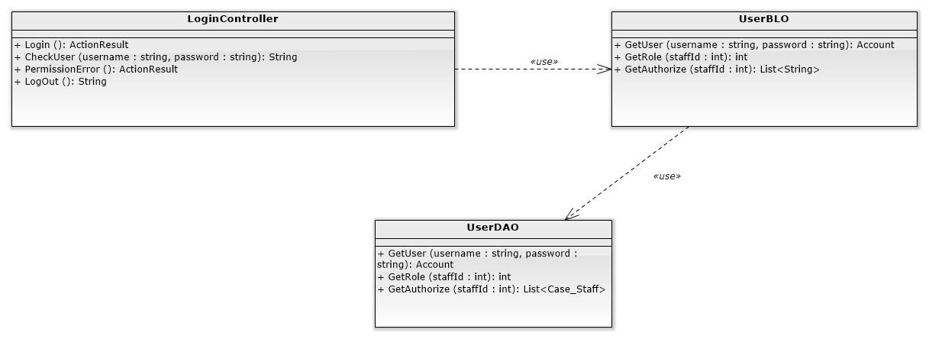

#### Screen design

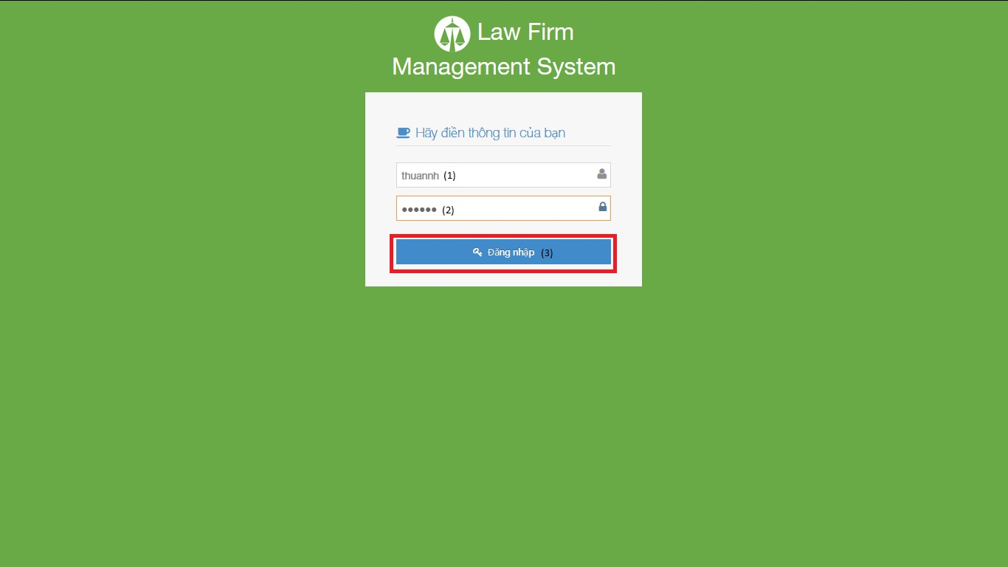

|  |  |  |  |  |
| --- | --- | --- | --- | --- |
| No | Object/ControlName | Type | Required | Description |
| 1 | Tên đăng nhập | Textbox | Yes | Username for login |
| 2 | Mật khẩu | Textbox | Yes | Password for login |
| 3 | Đăng nhập | Button | Yes | Click for login to website |

#### Sequence diagram

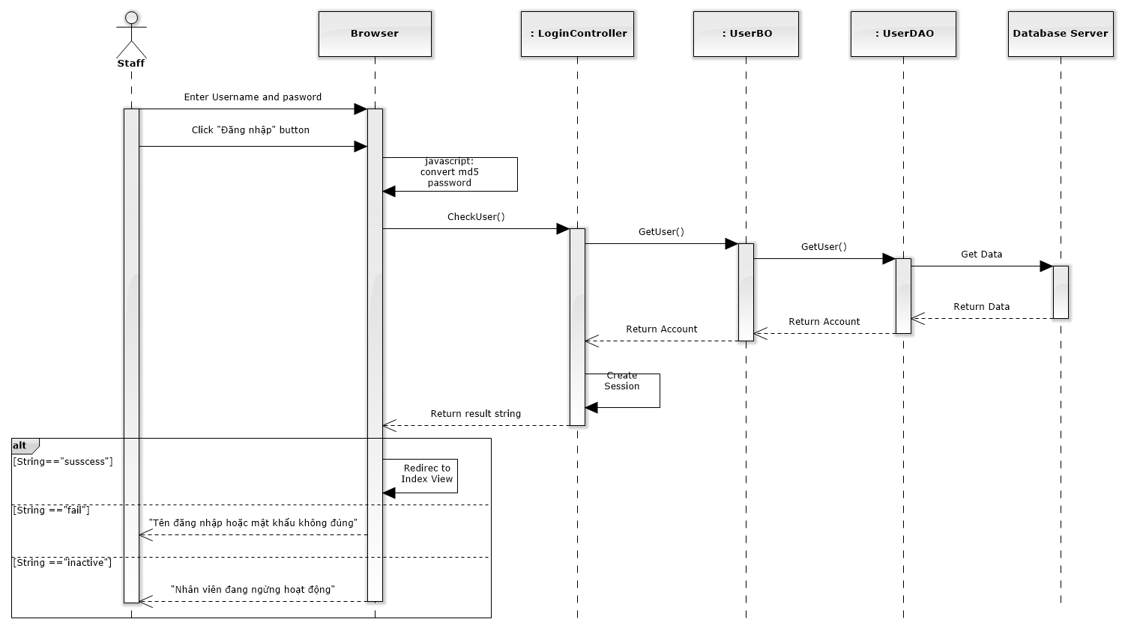

Figure 4-10: Login Sequence Diagram

### Change password

#### Class diagram

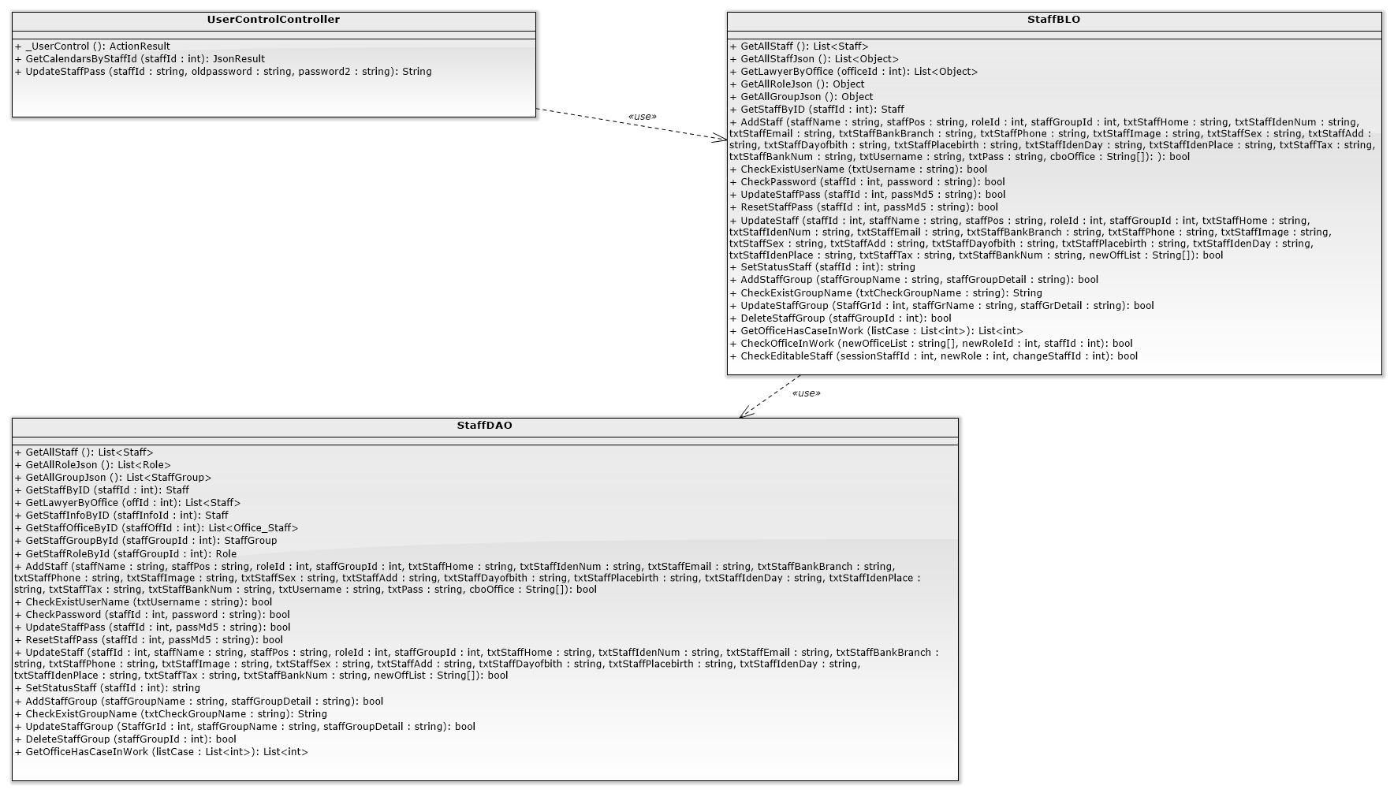

#### Screen design

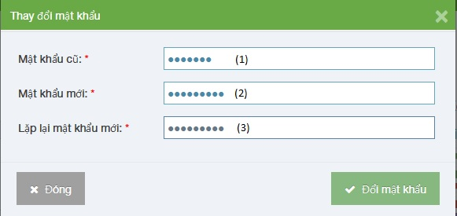

|  |  |  |  |  |
| --- | --- | --- | --- | --- |
| No | Object/ControlName | Type | Required | Description |
| 1 | Mật khẩu cũ | Textbox | Yes | Your old password |
| 2 | Mật khẩu mới | Textbox | Yes | Your new password |
| 3 | Lặp lại mật khẩu mới | Textbox | Yes | Re-input your new password |

#### Sequence diagram

Figure 4-11: Change Password Sequence Diagram

### View Home

#### Class diagram

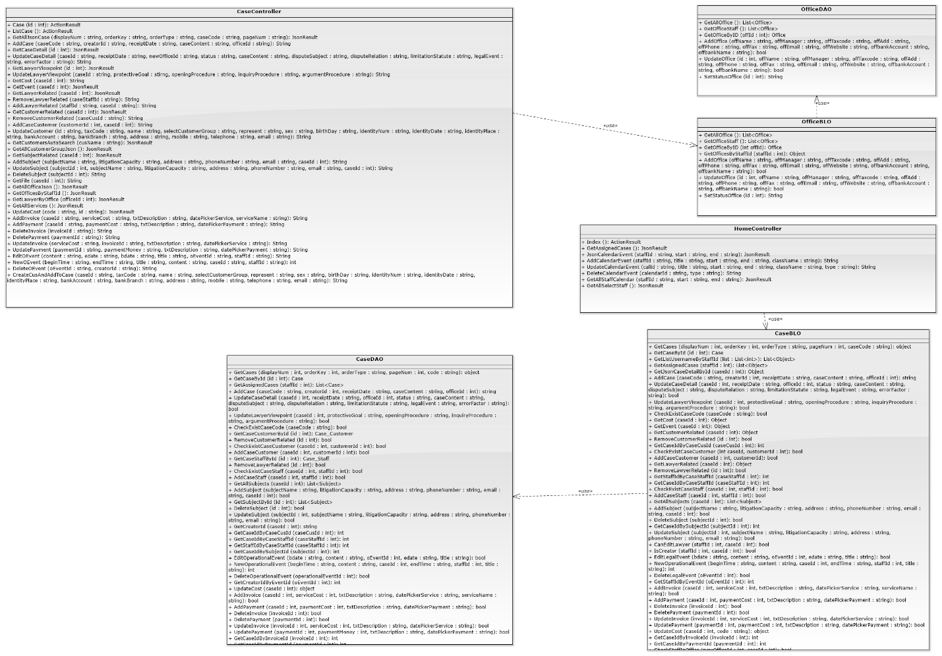

#### Screen design

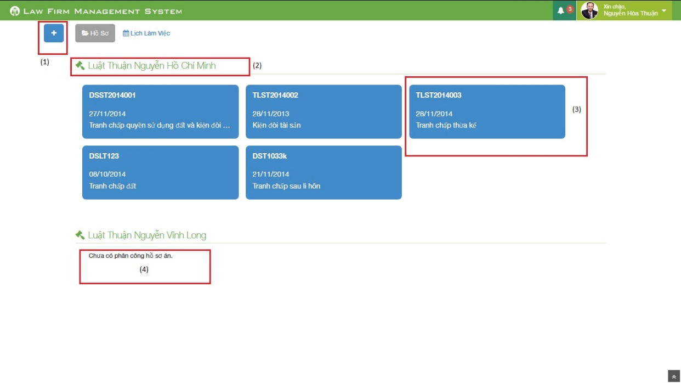

Figure 212: Home Screen Image

|  |  |  |  |  |
| --- | --- | --- | --- | --- |
| No | Object/ControlName | Type | Required | Description |
| 1 | Plus | Button | Yes | Click to show popup for add new case |
| 2 | Office name | Label | Yes | Show name of office the staff work in |
| 3 | Case information | Button | Yes | Show important information of the case, click and redirect to view case detail page |
| 4 | “Chưa có phân công hồ sơ án” | Label | Yes | If the office have no “Đang thụ lý” case, message will be show |

#### Sequence diagram

Figure 4-12: View Home Sequence Diagram

### Notify

#### Class diagram

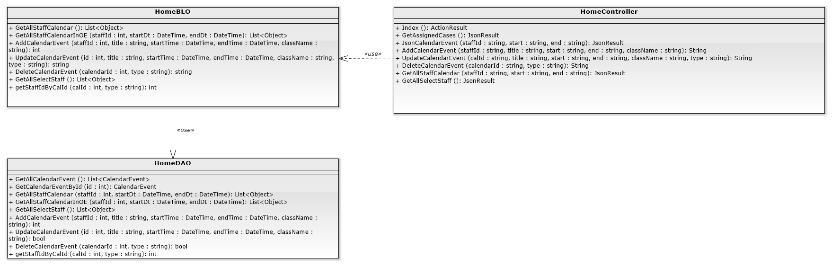

#### Screen design

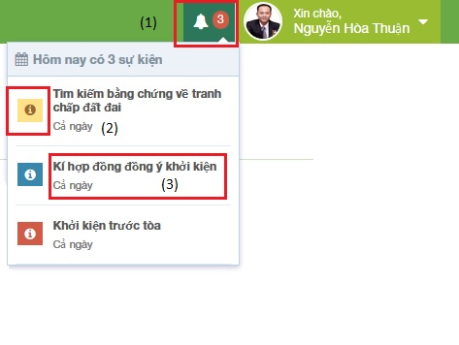

Figure 213: Notify Event Screen Image

|  |  |  |  |  |
| --- | --- | --- | --- | --- |
| No | Object/ControlName | Type | Required | Description |
| 1 | Event count | Label | Yes | Event quantity in “today” need to do. If there is at least 1 event, ring the bell |
| 2 | Priority | Icon | Yes | Show priority of event |
| 3 | Title | Label | Yes | Show title and time range of event |

#### Sequence diagram

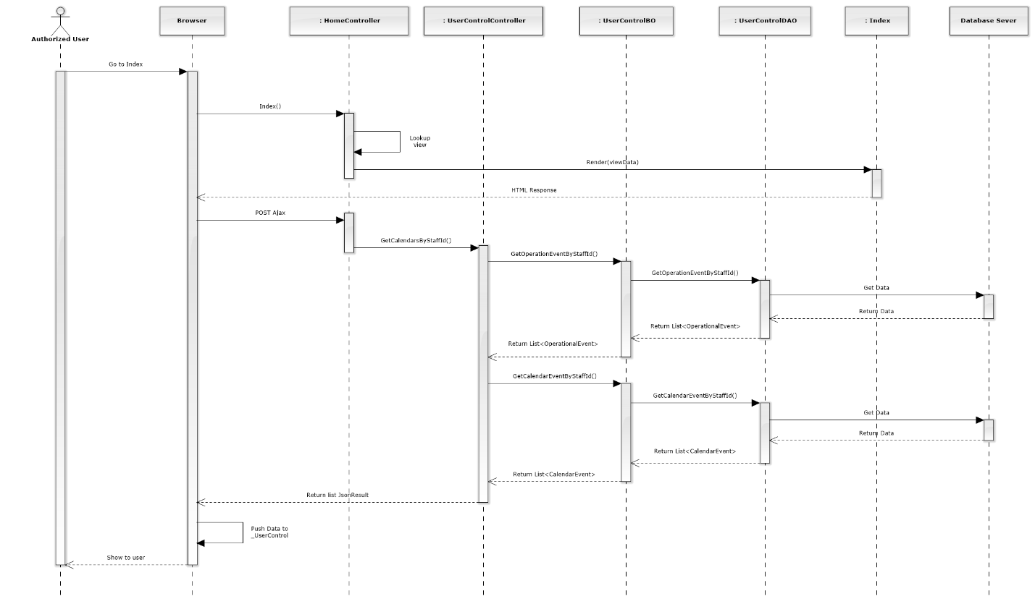

Figure 4-13: Notify Sequence Diagram

### List Calendar Events

#### Class diagram

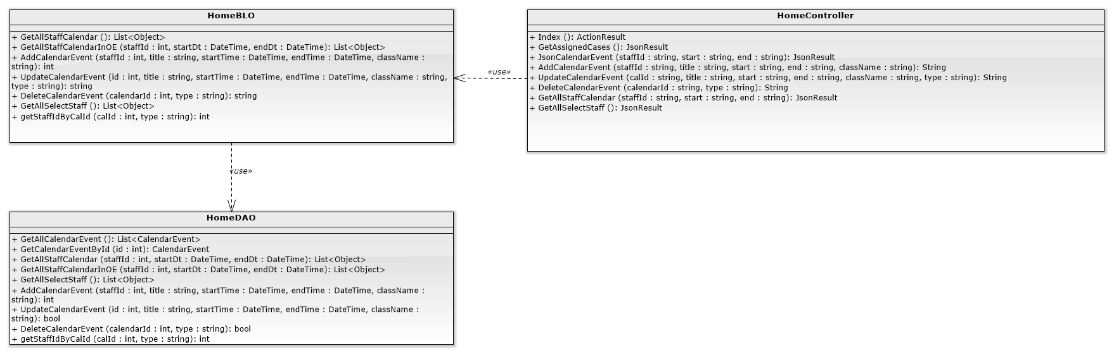

#### Screen design

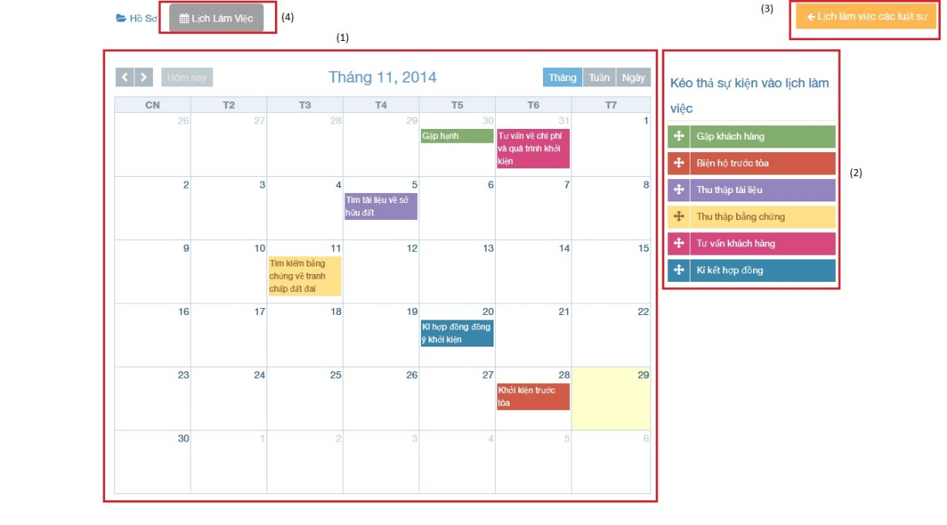

Figure 215: :List calendar events

|  |  |  |  |  |
| --- | --- | --- | --- | --- |
| No | Object/ControlName | Type | Required | Description |
| 1 | Calendar | Full Calendar | Yes | Show all event of Staff on calendar |
| 2 | Dropable event | Object | Yes | Drag and drop into calendar to create new event |
| 3 | Lịch làm việc của các luật sư | Button | Yes | Show other staff calendar pop-up |
| 4 | “Lịch làm việc” | Label | Yes | Tab for view calendar events |

#### Sequence diagram

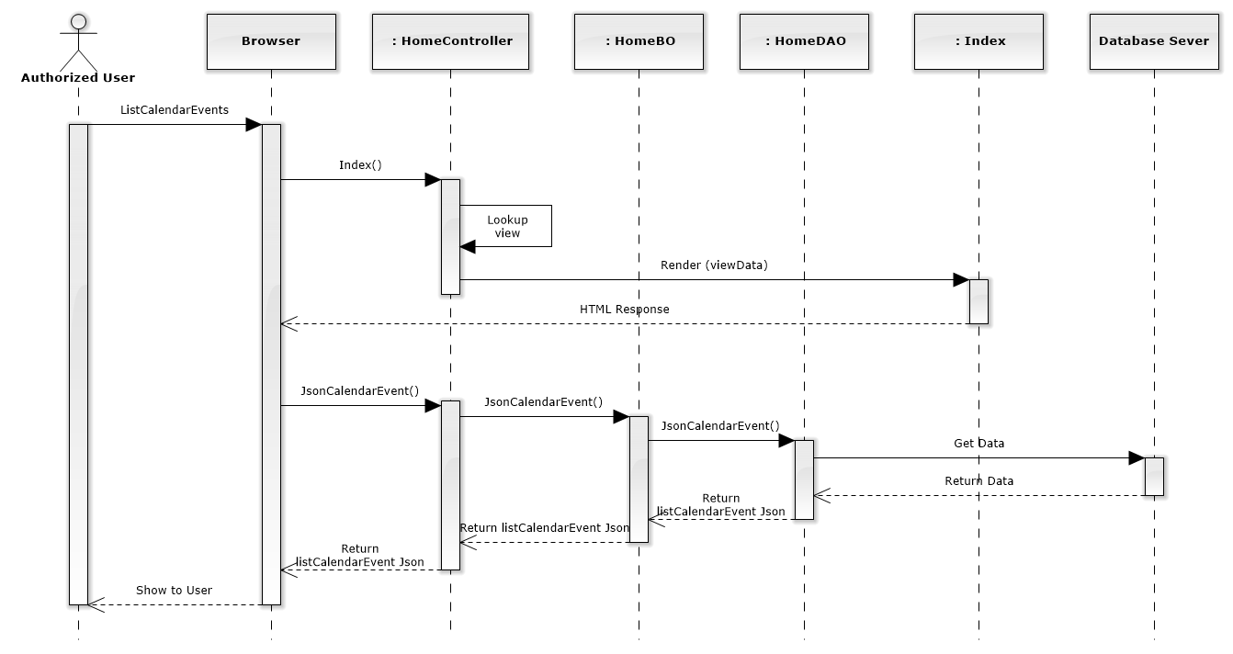

Figure 152: List Calendar Events Sequence Diagram

### Add new calendar event

#### Screen design

#### 

|  |  |  |  |  |
| --- | --- | --- | --- | --- |
| No | Object/ControlName | Type | Required | Description |
| 1 | “Tên Sự Kiện Mới:” | Label | Yes | View name event |
| 2 | “Tên sự kiện” | Textbox | Yes | Name event |
| 3 | “Bỏ Qua” | Button | Yes | Click to close Add new calendar event pop-up |
| 4 | “Xác Nhận” | Button | Yes | Click to create a new calendar event |

#### Sequence diagram

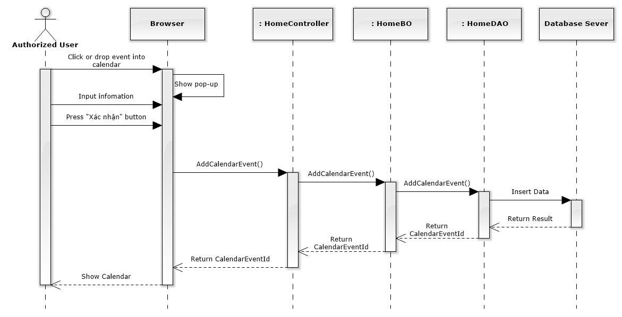

Figure 153: Add New Calendar Event Sequence Diagram

### Edit calendar event

#### Screen design

#### 

|  |  |  |  |  |
| --- | --- | --- | --- | --- |
| No | Object/ControlName | Type | Required | Description |
| 1 | “Tên sự kiện” | Textbox | Yes | Name event |
| 2 | “Lưu” | Button | Yes | Click to save edit new calendar event |
| 3 | “Đóng” | Button | Yes | Click to close Edit new calendar event pop-up |

#### Sequence diagram

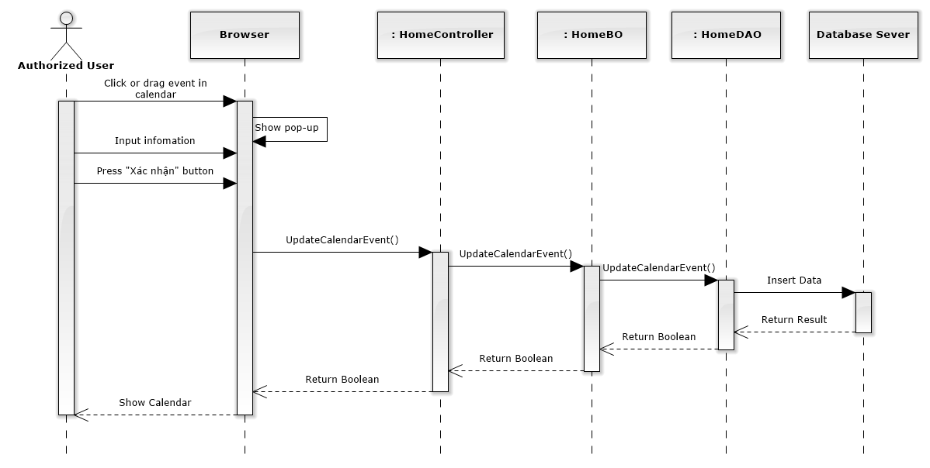

Figure 154: Edit Calendar Event Sequence Diagram

### Delete calendar event

#### Screen design

#### 

|  |  |  |  |  |
| --- | --- | --- | --- | --- |
| No | Object/ControlName | Type | Required | Description |
| 1 | “Tên sự kiện” | Textbox | Yes | Name event |
| 2 | “Xóa sự kiện” | Button | Yes | Click to delete calendar event |
| 3 | “Đóng” | Button | Yes | Click to close Delete calendar event pop-up |

#### Sequence diagram

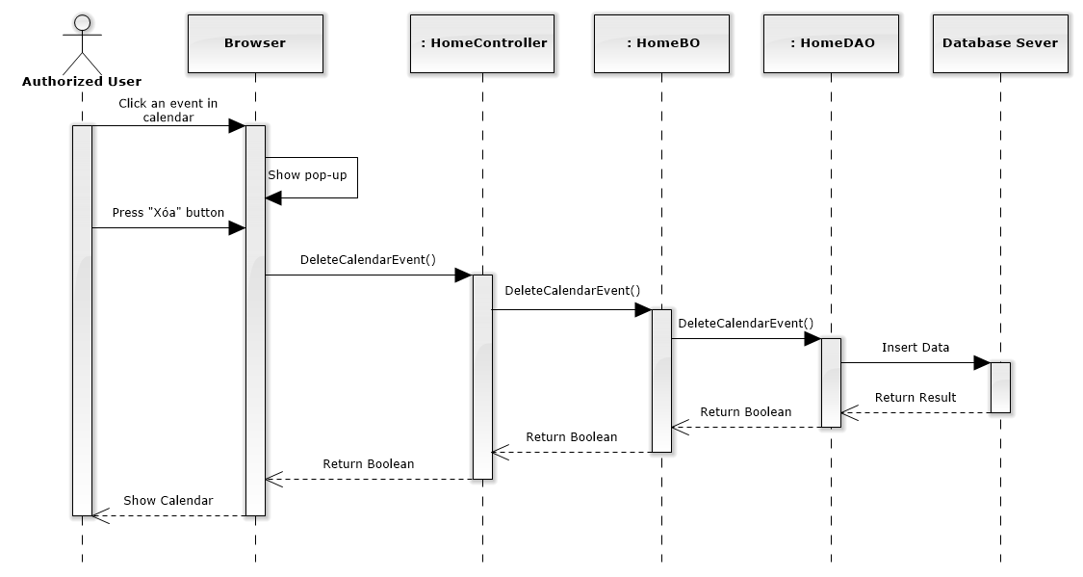

Figure 155: Delete Calendar Event Sequence Diagram

### List all cases

#### Class diagram

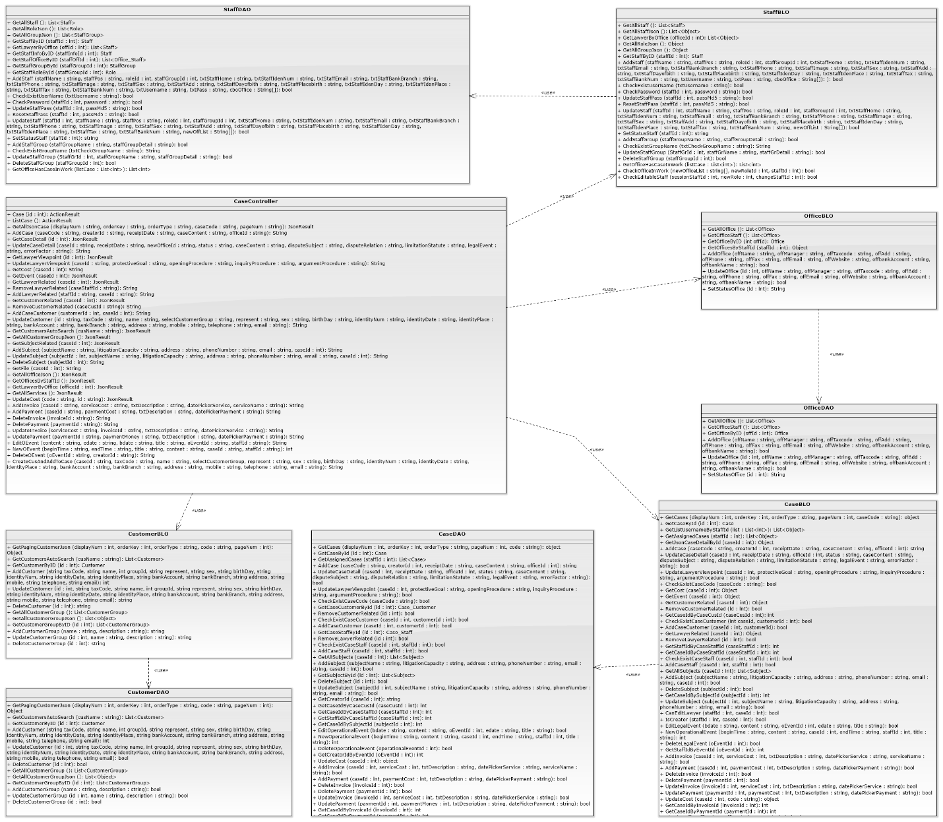

#### Screen design

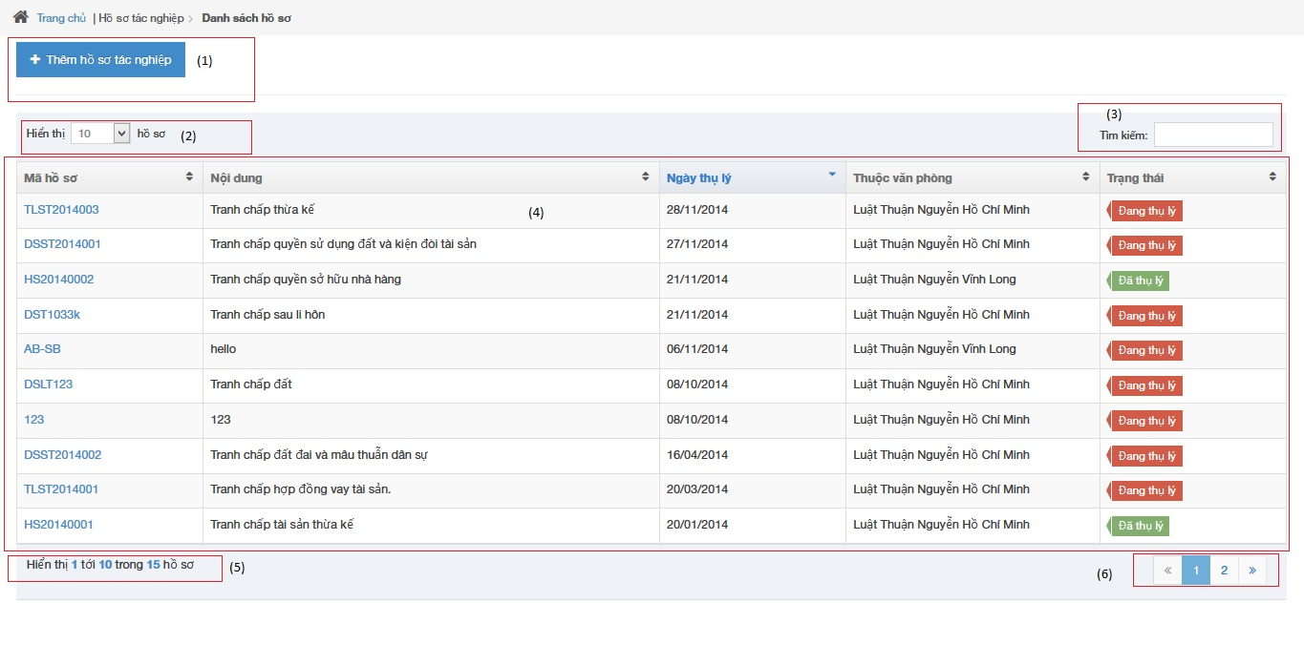

|  |  |  |  |  |
| --- | --- | --- | --- | --- |
| No | Object/ControlName | Type | Required | Description |
| 1 | “Thêm hồ sơ tác nghiệp” | Button | Yes | Click to show popup for add new case |
| 2 | Line count | Dropdown list | Yes | Select line quantity in table |
| 3 | “Tìm kiếm” | Textbox | Yes | Search case automatically |
| 4 | View all cases | Table | Yes | Show all of case |
| 5 | Case count | Label | Yes | Show case quantity of page in table |
| 6 | Paging | Button | Yes | List case page by page |

#### Sequence diagram

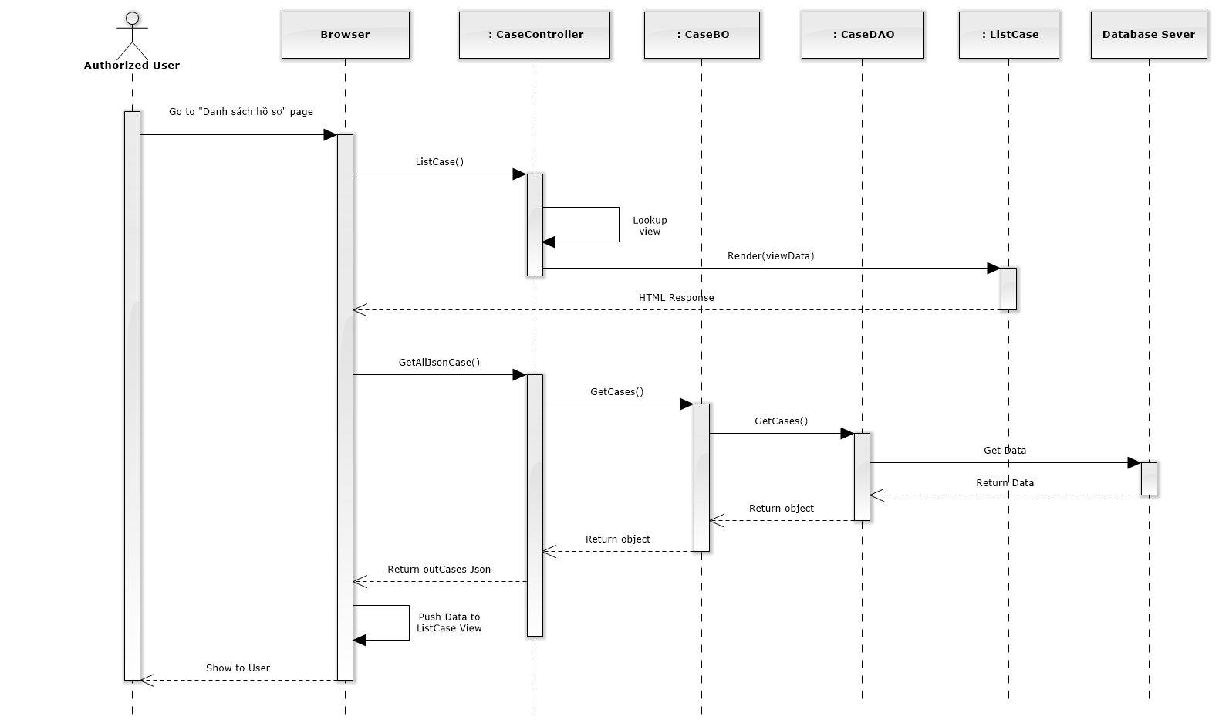

Figure 156: List All Cases Sequence Diagram

### Add new case

#### Screen design

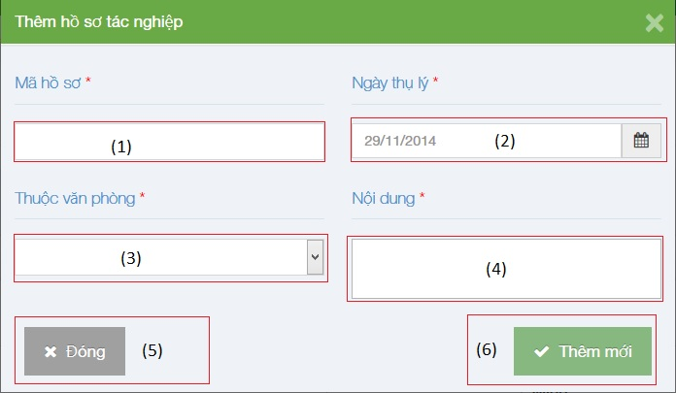

|  |  |  |  |  |
| --- | --- | --- | --- | --- |
| No | Object/ControlName | Type | Required | Description |
| 1 | “Mã hồ sơ” | Textbox | Yes | Case code |
| 2 | “Ngày thụ lý” | Textbox list | Yes | Receipt date |
| 3 | “Thuộc văn phòng” | Textbox | Yes | Choose one office |
| 4 | “Nội dung” | Textbox | Yes | Case content |
| 5 | “Đóng” | Button | Yes | Click to close modal popup |
| 6 | “Thêm mới” | Button | Yes | Click to create a new case |

#### Sequence diagram

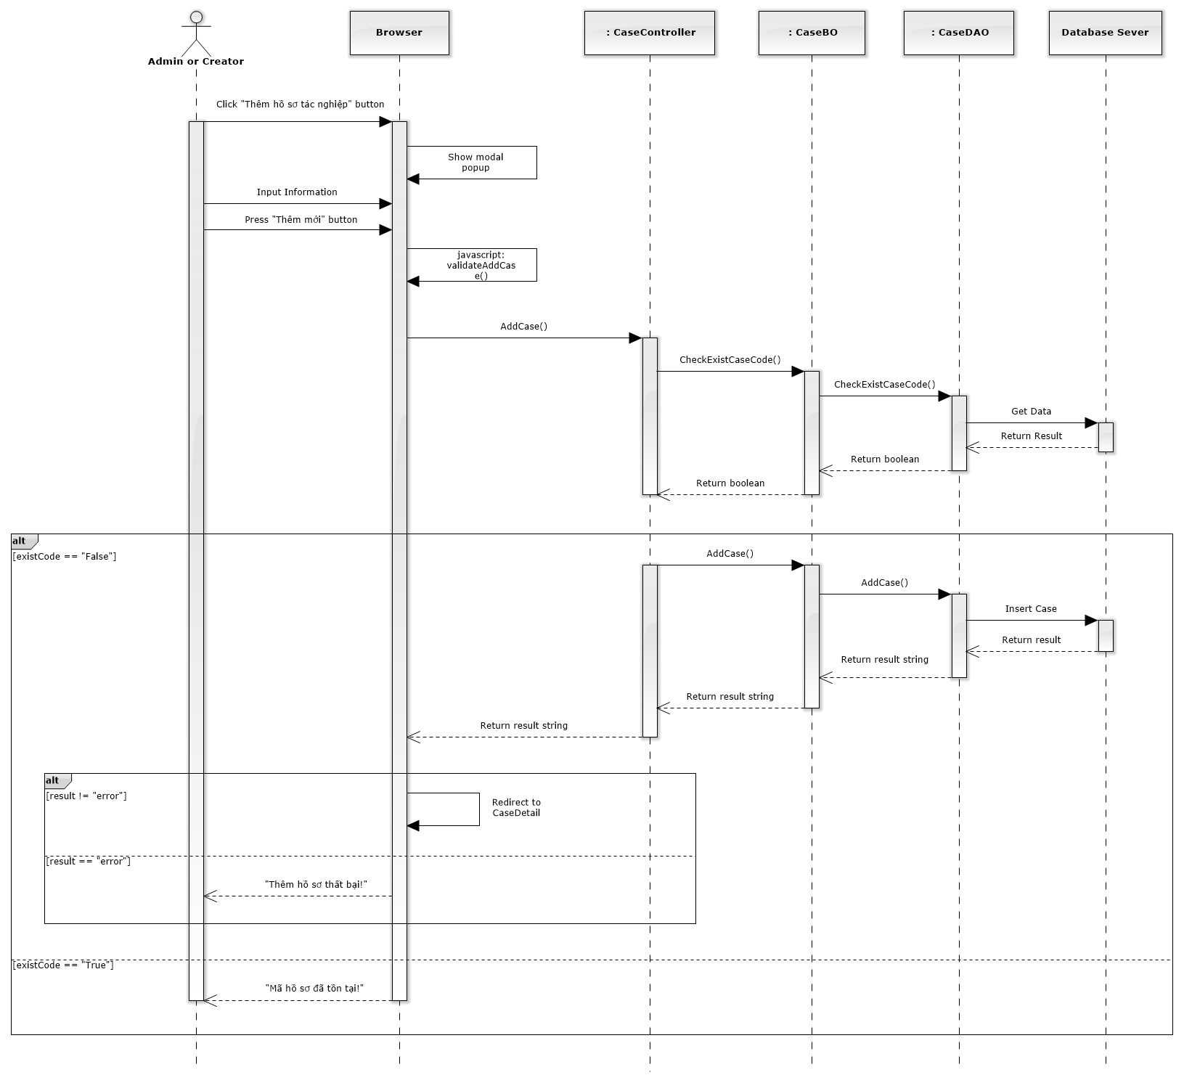

Figure 157: Add New Case Sequence Diagram

### Search case

#### Screen design

#### 

|  |  |  |  |  |
| --- | --- | --- | --- | --- |
| No | Object/ControlName | Type | Required | Description |
| 1 | “Tìm kiếm” | Textbox | Yes | Search case automatically |
| 2 | View all cases | Table | Yes | Show all result of case after searching |
| 3 | Case contain “Tranh chấp quyền” | Label | Yes | Show a word that contain in search textbox |

#### Sequence diagram

### View case detail

#### Screen design

#### 

|  |  |  |  |  |
| --- | --- | --- | --- | --- |
| No | Object/ControlName | Type | Required | Description |
| 1 | “Danh sách hồ sơ” | Link | Yes | Redirect to view all cases |
| 2 | Edit | Button | Yes | Must be click to edit infor |
| 3 | “Mã hồ sơ” | Textbox | Yes | Case code |
| 4 | “Ngày thụ lý” | Textbox | Yes | Receipt date |
| 5 | “Thuộc văn phòng” | Textbox | Yes | Choose one office |
| 6 | “Trạng thái” | Textbox | Yes | Case status |
| 7 | “Nội dung tranh chấp” | Textbox | Yes | The contents of dispute |
| 8 | “Đối tượng tranh chấp” | Textbox | Yes | The subject of dispute |
| 9 | “Quan hệ tranh chấp” | Textbox | Yes | The relation of dispute |
| 10 | “Thời hiệu” | Textbox | Yes | The statute of limitations |
| 11 | “Sự kiện pháp lý” | Textbox | Yes | Legal event |
| 12 | “Yếu tố lỗi” | Textbox | Yes | Error factor |
| 13 | “Hủy chỉnh sửa” | Button | Yes | Cancel edit infor |
| 14 | “Lưu chỉnh sửa” | Button | Yes | Save new infor |

#### Sequence diagram

### List operation events

#### Screen design

#### 

|  |  |  |  |  |
| --- | --- | --- | --- | --- |
| No | Object/ControlName | Type | Required | Description |
| 1 | Thêm sự kiện | Button | Yes | Click to add new operation event |
| 2 | Hoàn thành | Button | Yes | Click to finish edit operation event |
| 3 | Thu nhỏ / Mở rộng | Button | Yes | Reduce / Expand |
| 4 | Title | Label | Yes | Title of Operation Event |
| 5 | Time range | Label | Yes | Click to choose begin time and end time of event |
| 6 | Staff username | Label | Yes | The lawyer who create a case |
| 7 | Content | Information | Yes | Content of Operation Event |
| 8 | Pencil | Button | Yes | Edit operation event |
| 9 | Trash | Button | Yes | Delete operation event |

#### Sequence diagram

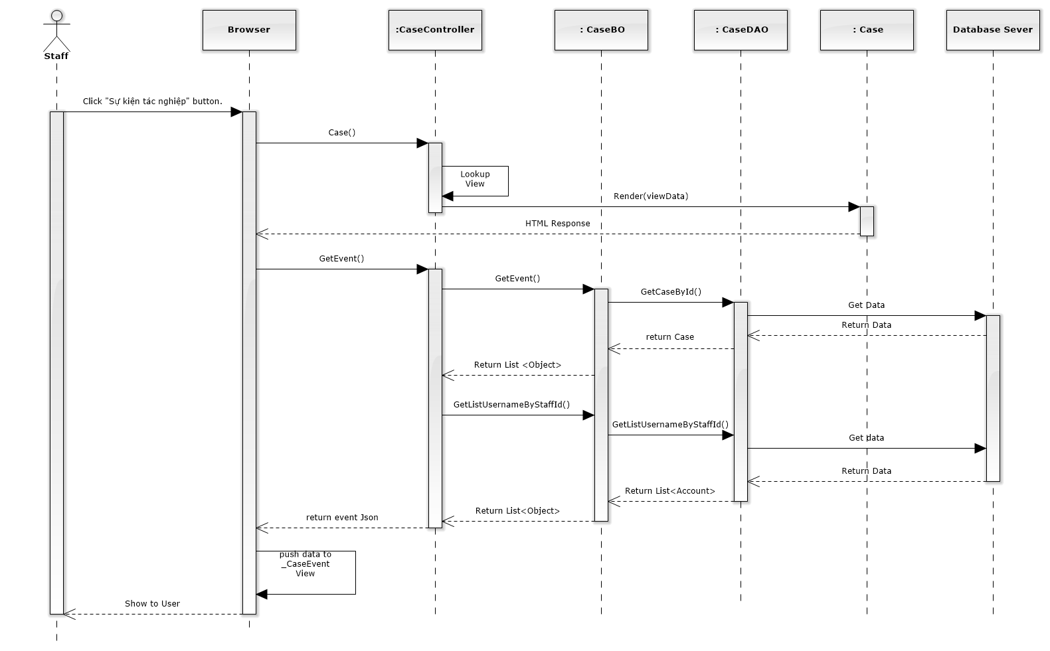

Figure 158: List Operation Events Sequence Diagram

### Add new operation event

#### Screen design

#### 

|  |  |  |  |  |
| --- | --- | --- | --- | --- |
| No | Object/ControlName | Type | Required | Description |
| 1 | Time range | Button | Yes | Click to choose begin time and end time of event |
| 2 | Title | Table | Yes | Title of Operation Event |
| 3 | Content | Label | Yes | Content of Operation Event |
| 4 | “Đóng” | Button | Yes | Click to close add new operation event |
| 5 | “Tạo sự kiện” | Button | Yes | Click to add new operation event |

#### Sequence diagram

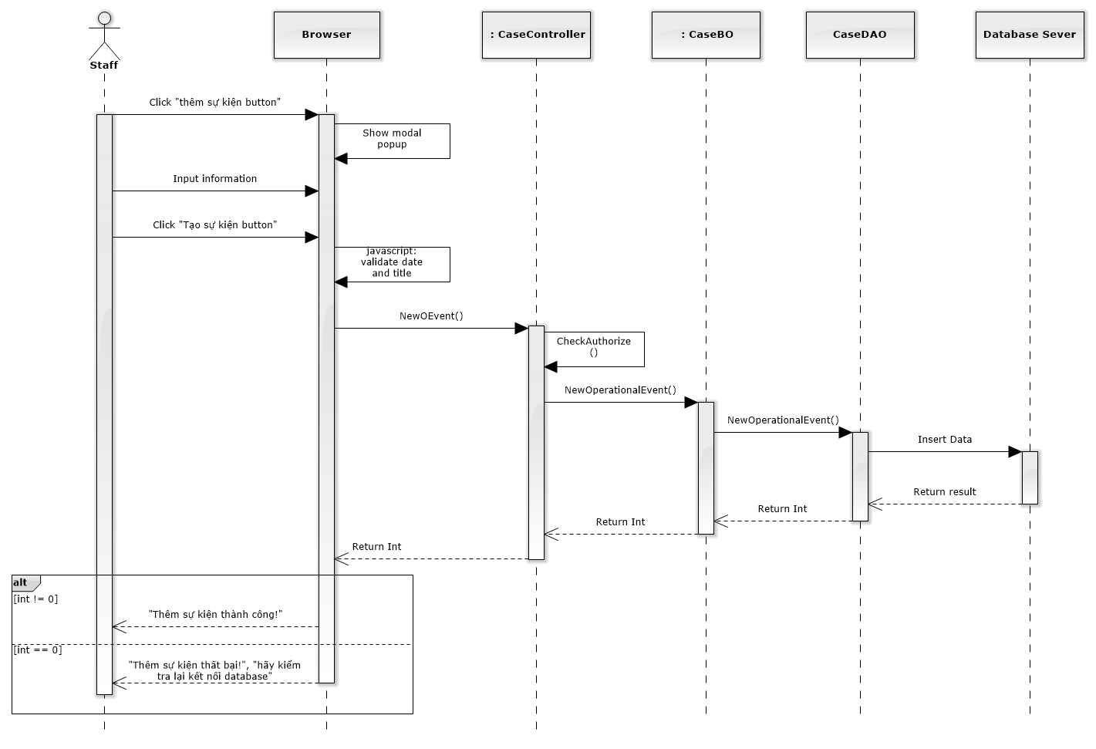

Figure 159: Add New Operation Event Sequence Diagram

### Edit operation event

#### Screen design

#### 

|  |  |  |  |  |
| --- | --- | --- | --- | --- |
| No | Object/ControlName | Type | Required | Description |
| 1 | Time range | Button | Yes | Click to choose begin time and end time of event |
| 2 | Title | Table | Yes | Title of Operation Event |
| 3 | Content | Label | Yes | Content of Operation Event |
| 4 | “Đóng” | Button | Yes | Click to close edit operation event |
| 5 | “Lưu chỉnh sửa” | Button | Yes | Click to edit operation event |

#### Sequence diagram

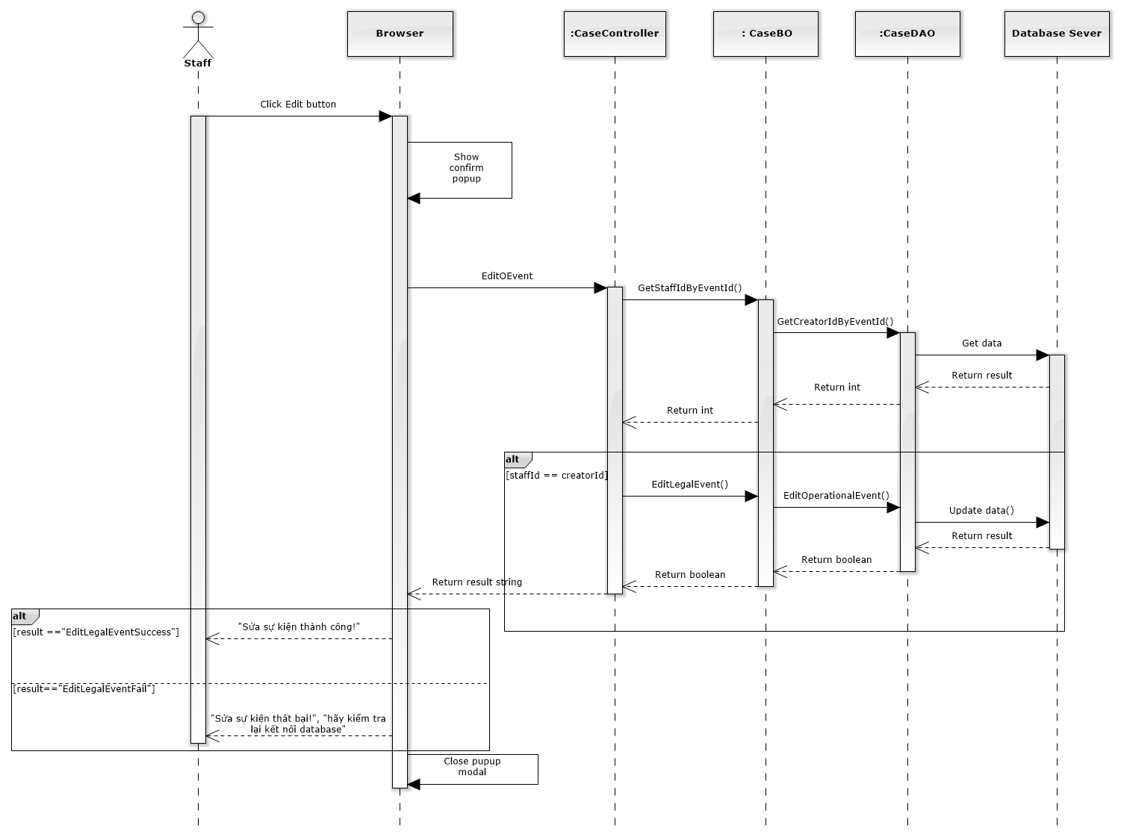

Figure 160: Edit Operation Event Sequence Diagram

### Delete operation event

#### Screen design

#### 

|  |  |  |  |  |
| --- | --- | --- | --- | --- |
| No | Object/ControlName | Type | Required | Description |
| 1 | “Bỏ qua” | Button | Yes | Click to close delete operation event |
| 2 | “Xác nhận” | Button | Yes | Click to delete operation event |

#### Sequence diagram

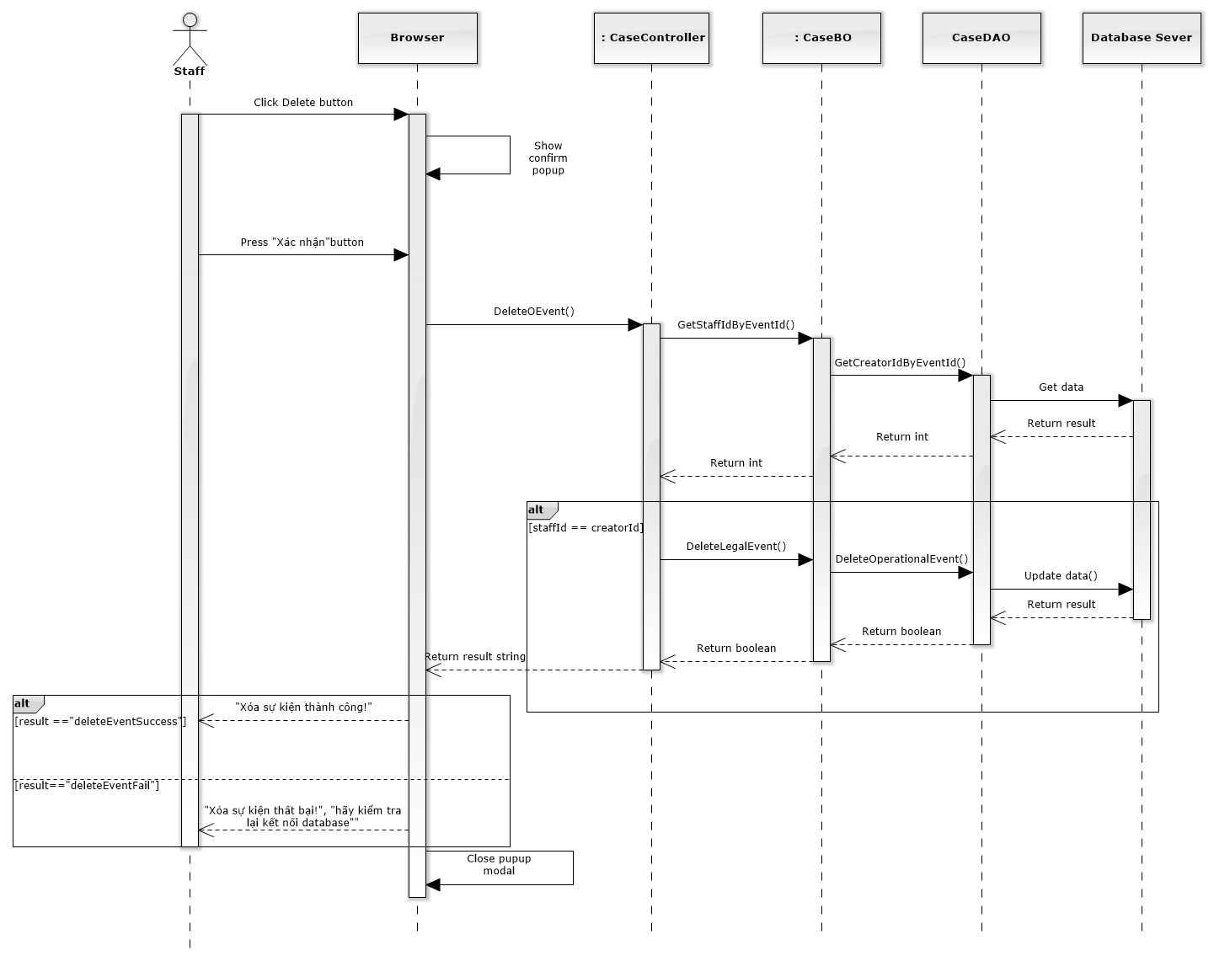

Figure 161: Delete Operation Event Sequence Diagram

##### Manage Lawyer Related

Reference to DVD: <root>/Documents/LFMS Project Document - Full Report.docx

##### Manage Customer Related

Reference to DVD: <root>/Documents/LFMS Project Document - Full Report.docx

##### Manage Subject Related

Reference to DVD: <root>/Documents/LFMS Project Document - Full Report.docx

##### Manage Document Related

Reference to DVD: <root>/Documents/LFMS Project Document - Full Report.docx

##### Manage Used Service

Reference to DVD: <root>/Documents/LFMS Project Document - Full Report.docx

##### Manage Payment

Reference to DVD: <root>/Documents/LFMS Project Document - Full Report.docx

### Manage Customer Group

#### Class diagram

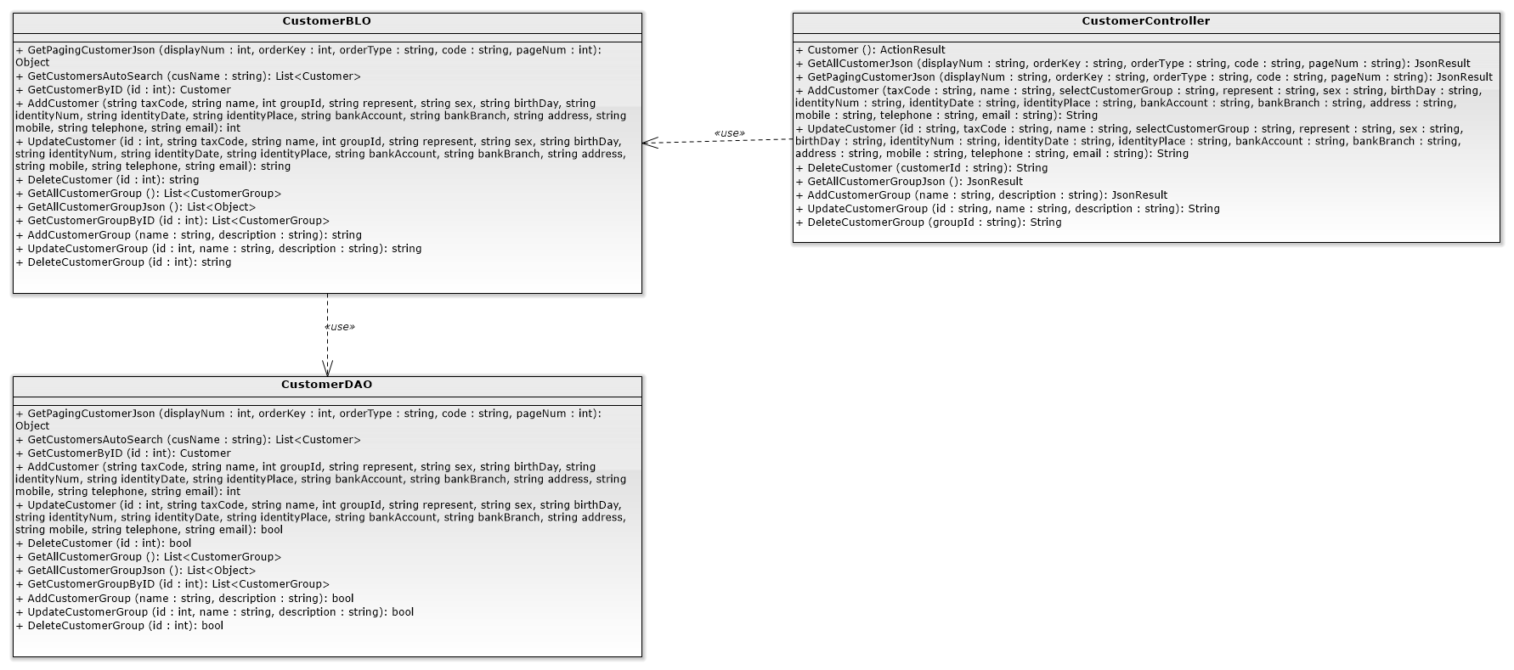

### List customers

#### Class diagram

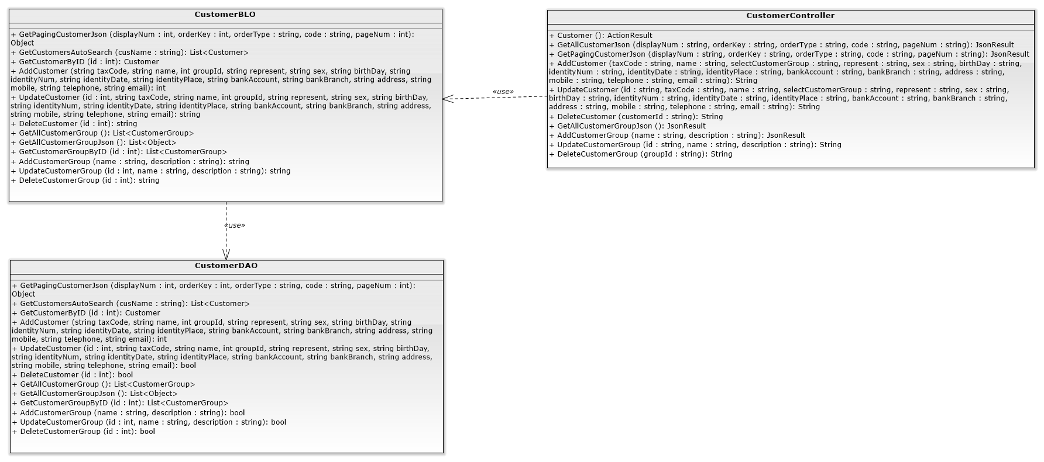

#### Screen design

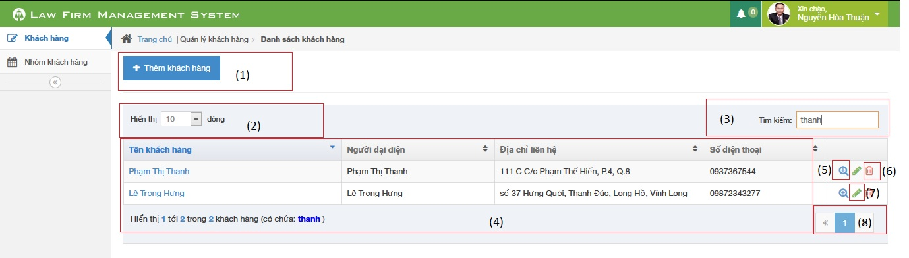

|  |  |  |  |  |
| --- | --- | --- | --- | --- |
| No | Object/ControlName | Type | Required | Description |
| 1 | Thêm khách hàng | Button | Yes | Show Add new customer pop-up |
| 2 | Number of rows | Combo-box | Yes | Choose number of rows in table |
| 3 | Search | Textbox | Yes | Search customer |
| 4 | Customer table | Table | Yes | List Customer |
| 5 | View customer detail | Icon | Yes | Show Customer detail pop-up |
| 6 | Delete customer | Icon | Yes | Delete customer |
| 7 | Edit customer | Icon | Yes | Show edit customer pop-up |
| 8 | Paging | Button | Yes | Paging the customer list |

#### Sequence diagram

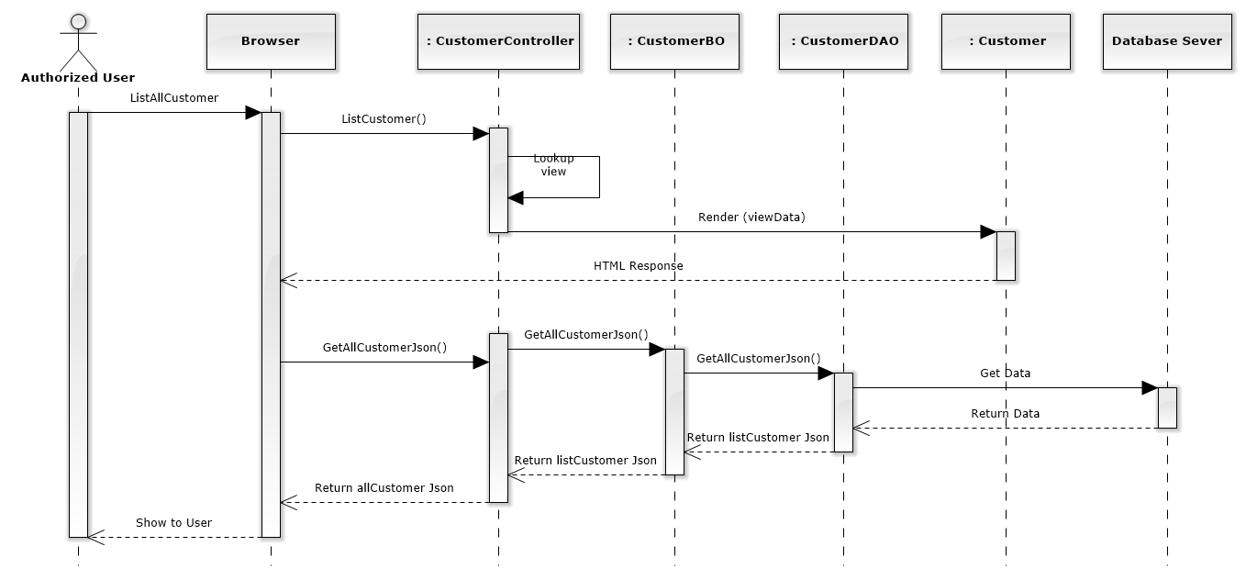

Figure 163: List Customers Sequence Diagram

### Add new customer

#### Screen design

#### 

|  |  |  |  |  |
| --- | --- | --- | --- | --- |
| No | Object/ControlName | Type | Required | Description |
| 1 | Tên Khách hàng | Textbox | Yes | Customer name |
| 2 | Người đại diện | Textbox | Yes | Presentative |
| 3 | Ngày sinh | Date picker | Yes | Date of Birth |
| 4 | Ngày cấp CMND | Date picker | Yes | Identity Date |
| 5 | Số tài khoản | Textbox | Yes | Bank account |
| 6 | Mã số thuế | Textbox | Yes | Tax code |
| 7 | Điện thoại di động | Textbox | Yes | Mobile |
| 8 | Nhóm khách hàng | Combo-box | Yes | Customer group |
| 9 | Giới tính | Radio-button | Yes | Gender |
| 10 | Số CMND | Textbox | Yes | Identity Number |
| 11 | Nơi cấp CMND | Textbox | Yes | Identity Place |
| 12 | Tên ngân hàng | Textbox | Yes | Bank Branch |
| 13 | Email | Textbox | Yes | Email |
| 14 | Điện thoại cố định | Textbox | Yes | Phone |
| 15 | Địa chỉ | Text area | Yes | Address |
| 16 | Làm trống | Button | Yes | Clear all field |
| 17 | Thêm mới | Button | Yes | Add new customer |

#### Sequence diagram

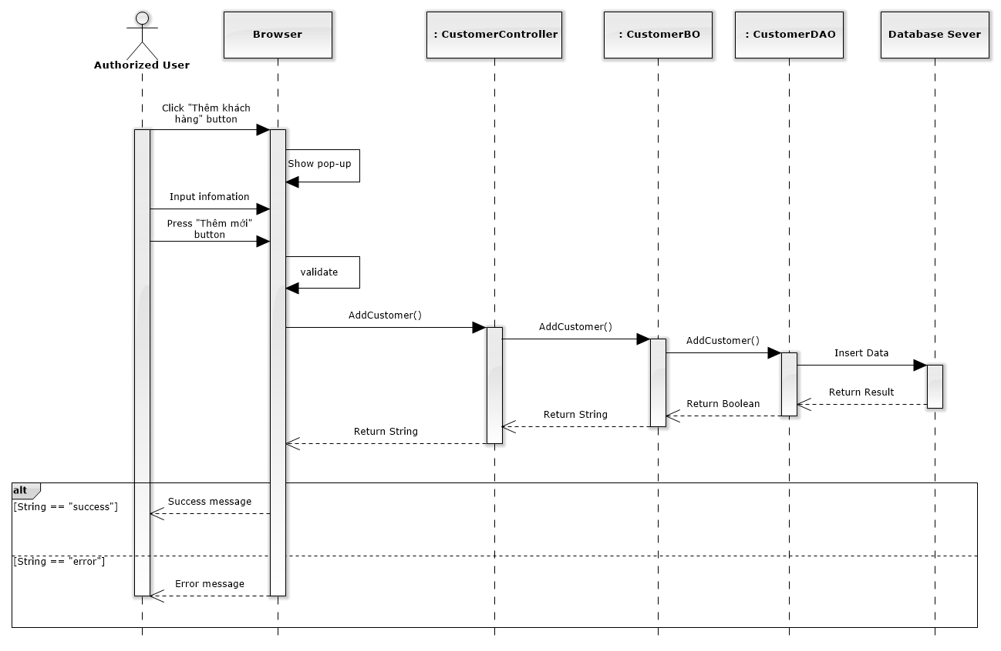

Figure 164: Add New Customer Sequence Diagram

### Edit customer

#### Screen design

#### 

|  |  |  |  |  |
| --- | --- | --- | --- | --- |
| No | Object/ControlName | Type | Required | Description |
| 1 | Tên Khách hàng | Textbox | Yes | Customer name |
| 2 | Người đại diện | Textbox | Yes | Presentative |
| 3 | Ngày sinh | Date picker | Yes | Date of Birth |
| 4 | Ngày cấp CMND | Date picker | Yes | Identity Date |
| 5 | Số tài khoản | Textbox | Yes | Bank account |
| 6 | Mã số thuế | Textbox | Yes | Tax code |
| 7 | Điện thoại di động | Textbox | Yes | Mobile |
| 8 | Nhóm khách hàng | Combo-box | Yes | Customer group |
| 9 | Giới tính | Radio-button | Yes | Gender |
| 10 | Số CMND | Textbox | Yes | Identity Number |
| 11 | Nơi cấp CMND | Textbox | Yes | Identity Place |
| 12 | Tên ngân hàng | Textbox | Yes | Bank Branch |
| 13 | Email | Textbox | Yes | Email |
| 14 | Điện thoại cố định | Textbox | Yes | Phone |
| 15 | Địa chỉ | Text area | Yes | Address |
| 16 | Đóng | Button | Yes | Close edit customer |
| 17 | Lưu chỉnh sửa | Button | Yes | Edit customer |

#### Sequence diagram

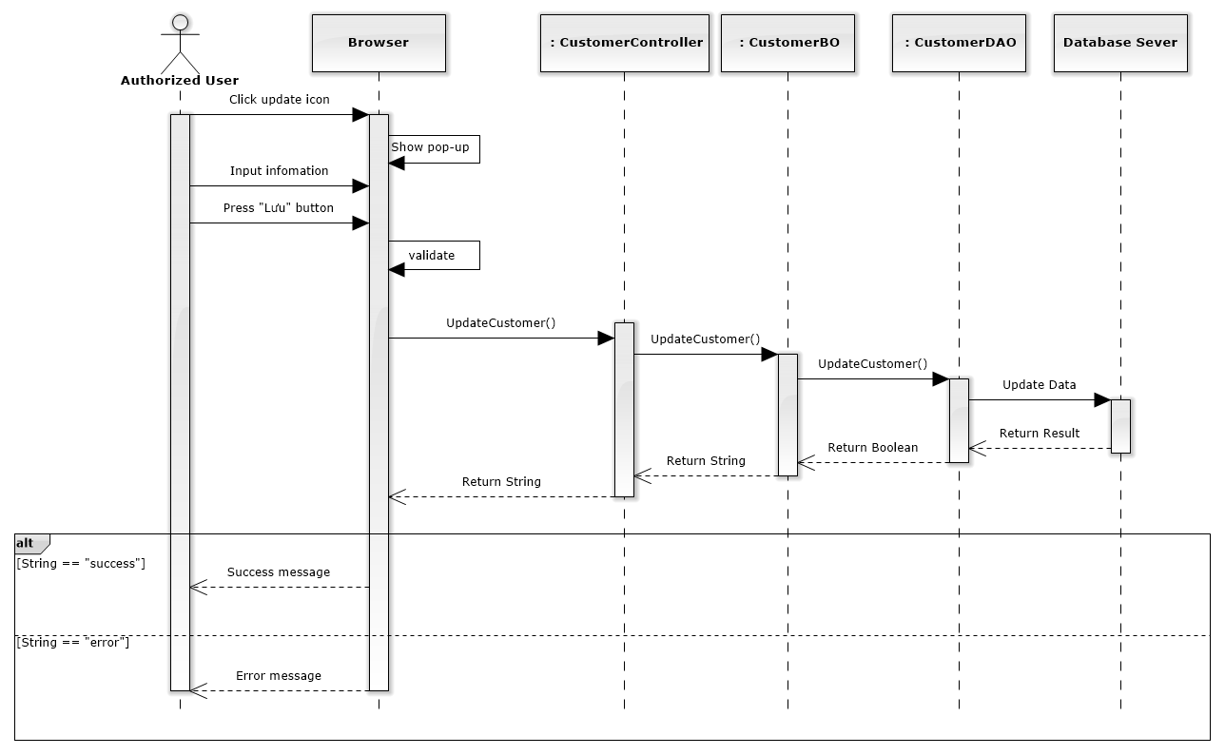

Figure 165: Edit Customer Sequence Diagram

### Delete customer

#### Screen design

#### 

|  |  |  |  |  |
| --- | --- | --- | --- | --- |
| No | Object/ControlName | Type | Required | Description |
| 1 | “Bỏ qua” | Button | Yes | Click to close delete customer |
| 2 | “Xác nhận” | Button | Yes | Click to delete customer |

#### Sequence diagram

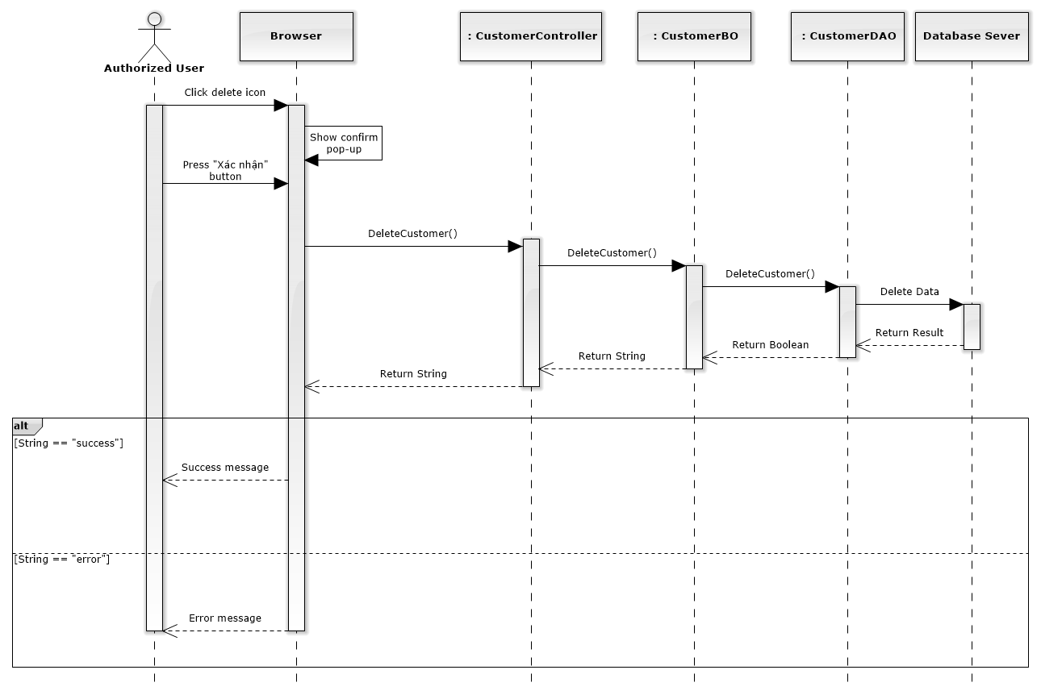

Figure 166: Delete Customer Sequence Diagram

### Manage Staff Group

Reference to DVD: <root>/Documents/LFMS Project Document - Full Report.docx

### List staffs

#### Class diagram

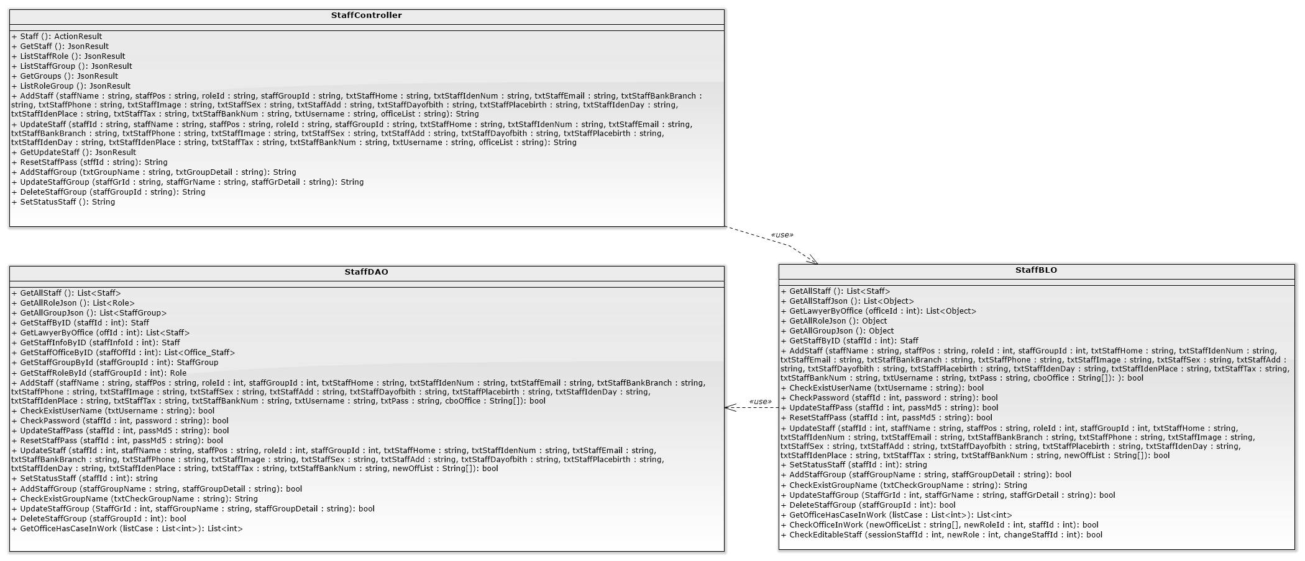

#### Screen design

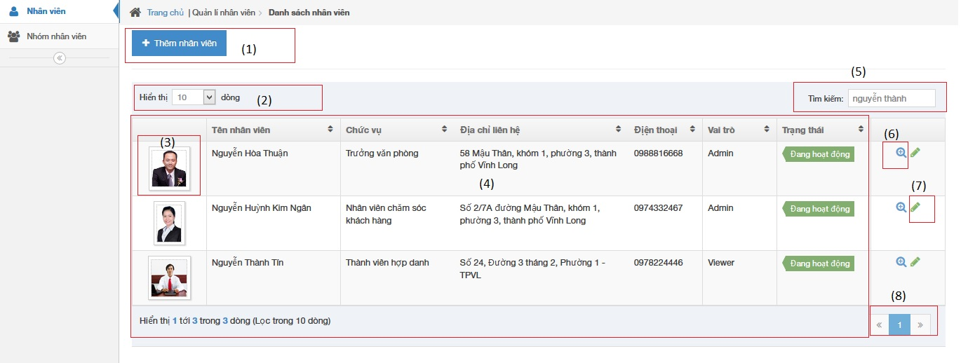

|  |  |  |  |  |
| --- | --- | --- | --- | --- |
| No | Object/ControlName | Type | Required | Description |
| 1 | Thêm nhân viên | Button | Yes | Click to show popup for add new staff |
| 2 | Number of rows | Combo-box | Yes | Choose number of rows in table |
| 3 | Image of staff | Image | Yes | Click to show popup detail of staff |
| 4 | List all staff | Table | Yes | List all staff |
| 5 | Tìm kiếm | Textbox | Yes | Search staff |
| 6 | View | Button | Yes | Click to show popup detail of staff |
| 7 | Edit | Button | Yes | Click to show popup edit detail of staff information. |
| 8 | Paging | Button | Yes | Paging page |

#### Sequence diagram

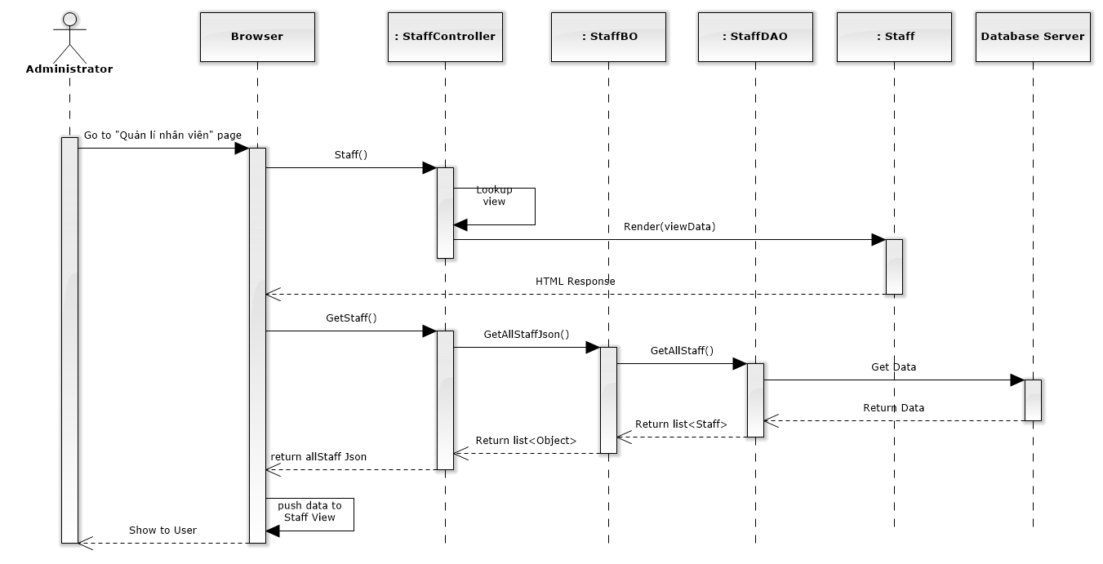

Figure 167: List Staffs Sequence Diagram

### Add new staff

#### Screen design

#### 

|  |  |  |  |  |
| --- | --- | --- | --- | --- |
| No | Object/ControlName | Type | Required | Description |
| 1 | Tên nhân viên | Textbox | Yes | Name of staff |
| 2 | Tên đăng nhập | Textbox | Yes | Username of staff |
| 3 | Chức vụ | Textbox | Yes | Position of staff |
| 4 | Giới tính | Radio button | Yes | Choose sex of staff |
| 5 | Số người phụ thuộc | Textbox | Yes | Number of dependents |
| 6 | Nhóm nhân viên | Textbox | Yes | Select group of staff |
| 7 | Ngày sinh | Datetime picker | Yes | Date of birth of staff |
| 8 | Nơi sinh | Textbox | Yes | Place of birth of staff |
| 9 | Điện thoại di động | Textbox | Yes | Phone number of staff |
| 10 | Điện thoại nhà riêng | Textbox | Yes | Telephone of staff |
| 11 | Email | Textbox | Yes | Email of staff |
| 12 | Địa chỉ liên hệ | Textbox | Yes | Address of staff |
| 13 | Thuộc văn phòng | Multiple select box | Yes | Select office of staff |
| 14 | Vai trò nhân viên | Select box | Yes | Select role of staff |
| 15 | CMND | Textbox | Yes | Indentity number of staff |
| 16 | Ngày cấp CMND | Datetime picker | Yes | Date of Identity of staff |
| 17 | Nơi cấp CMND | Textbox | Yes | Place of Identity of staff |
| 18 | Mã số thuế | Textbox | Yes | Tax number of staff |
| 19 | Số tài khoản | Textbox | Yes | Bank account number of staff |
| 20 | Chi nhánh ngân hàng | Textbox | Yes | Name of bank of staff |
| 21 | “Làm trống” | Button | Yes | Clear all field |
| 22 | “Thêm mới” | Button | Yes | Add new staff |
| 23 | Image of staff | Image | Yes | Image of staff |

#### Sequence diagram

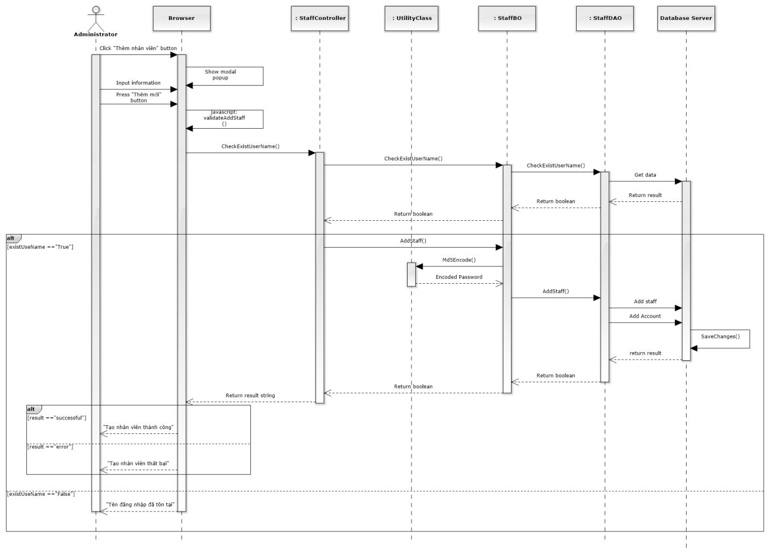

Figure 168: Add New Staff Sequence Diagram

### Edit staff

#### Screen design

#### 

|  |  |  |  |  |
| --- | --- | --- | --- | --- |
| No | Object/ControlName | Type | Required | Description |
| 1 | Image of staff | Image | Yes | Image of staff |
| 2 | Tên nhân viên | Textbox | Yes | Name of staff |
| 3 | Tên đăng nhập | Textbox | Yes | Username of staff |
| 4 | Chức vụ | Textbox | Yes | Position of staff |
| 5 | Giới tính | Radio button | Yes | Choose sex of staff |
| 6 | Số người phụ thuộc | Textbox | Yes | Number of dependents |
| 7 | Đặt lại mật khẩu | Link | Yes | Change staff password |
| 8 | Nhóm nhân viên | Textbox | Yes | Select group of staff |
| 9 | Ngày sinh | Datetime picker | Yes | Date of birth of staff |
| 10 | Nơi sinh | Textbox | Yes | Place of birth of staff |
| 11 | Điện thoại di động | Textbox | Yes | Phone number of staff |
| 12 | Điện thoại nhà riêng | Textbox | Yes | Telephone of staff |
| 13 | Email | Textbox | Yes | Email of staff |
| 14 | Địa chỉ liên hệ | Textbox | Yes | Address of staff |
| 15 | Vai trò nhân viên | Select box | Yes | Select role of staff |
| 16 | CMND | Textbox | Yes | Indentity number of staff |
| 17 | Ngày cấp CMND | Datetime picker | Yes | Date of Identity of staff |
| 18 | Nơi cấp CMND | Textbox | Yes | Place of Identity of staff |
| 19 | Mã số thuế | Textbox | Yes | Tax number of staff |
| 20 | Số tài khoản | Textbox | Yes | Bank account number of staff |
| 21 | Chi nhánh ngân hàng | Textbox | Yes | Name of bank of staff |
| 22 | “Đóng” | Button | Yes | Close edit staff |
| 23 | “Lưu chỉnh sửa” | Button | Yes | Save edit staff |

#### Sequence diagram

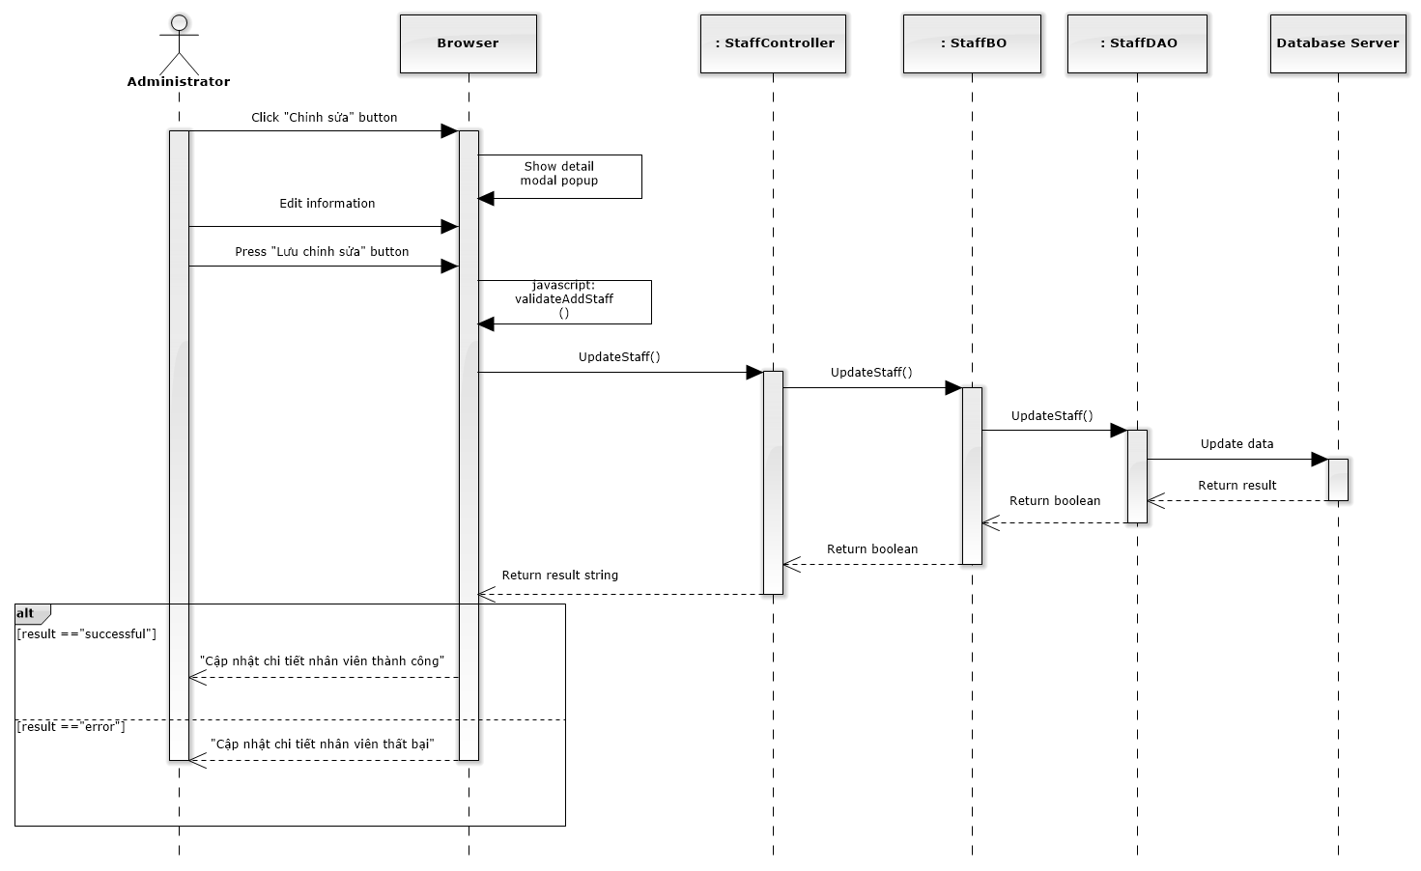

Figure 169: Edit Staff Sequence Diagram

### Deactivate/ Activate staff

#### Screen design

#### 

|  |  |  |  |  |
| --- | --- | --- | --- | --- |
| No | Object/ControlName | Type | Required | Description |
| 1 | “Bỏ qua” | Button | Yes | Click to close Deactive staff |
| 2 | “Xác nhận” | Button | Yes | Click to Deactive staff |
| 3 | Ngừng hoạt động | Link | Yes | Click to open confirm Deactive staff |

#### Sequence diagram

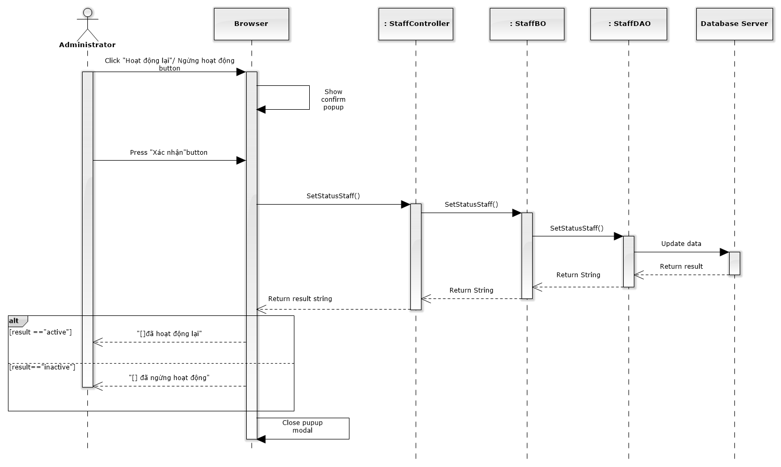

Figure 170: Deactivate / Activate Staff Sequence Diagram

### Reset password

#### Screen design

#### 

|  |  |  |  |  |
| --- | --- | --- | --- | --- |
| No | Object/ControlName | Type | Required | Description |
| 1 | “Bỏ qua” | Button | Yes | Click to close reset password staff |
| 2 | “Xác nhận” | Button | Yes | Click to reset password staff |
| 3 | Đặt lại mật khẩu | Link | Yes | Click to open reset password staff |

#### Sequence diagram

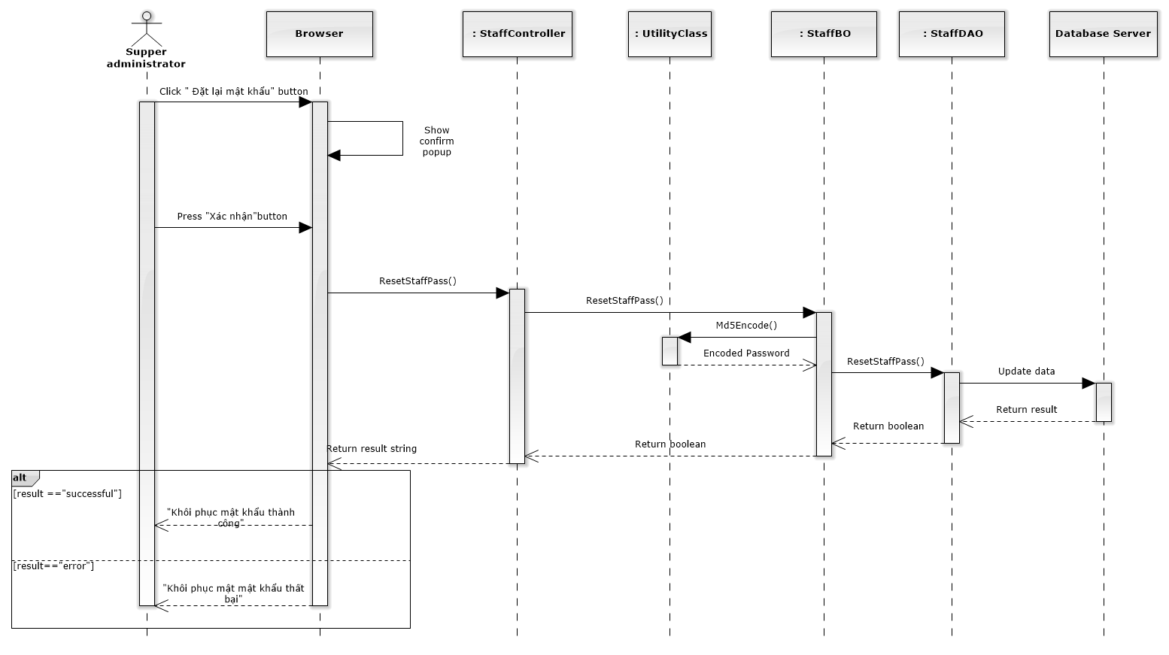

Figure 171: Reset Password Sequence Diagram

### Manage Service Type

#### Class diagram

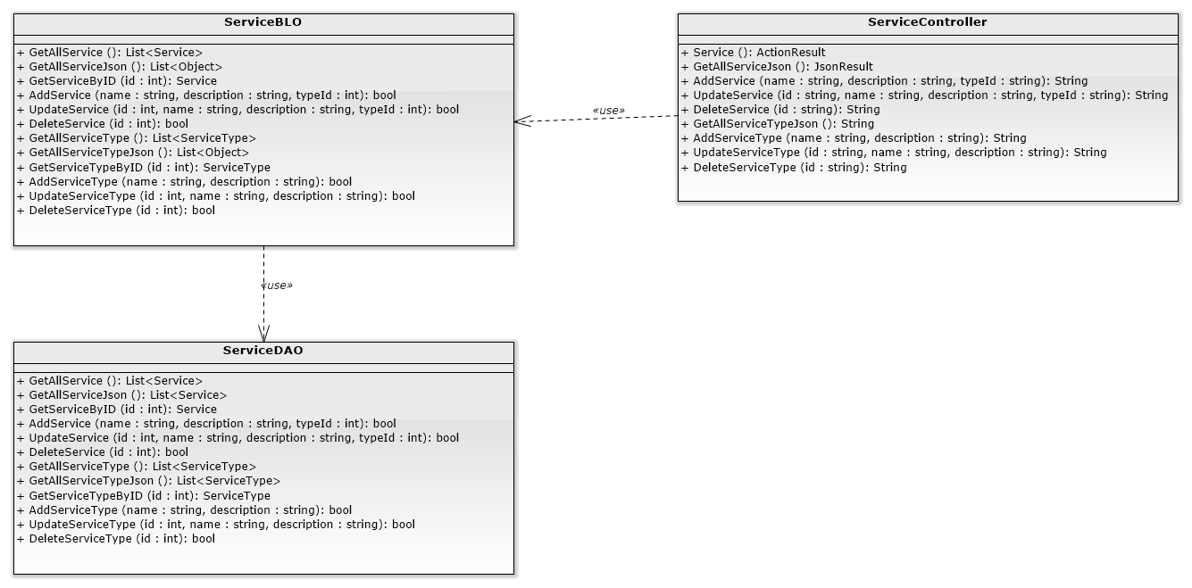

### List Services

#### Class diagram



#### Screen design

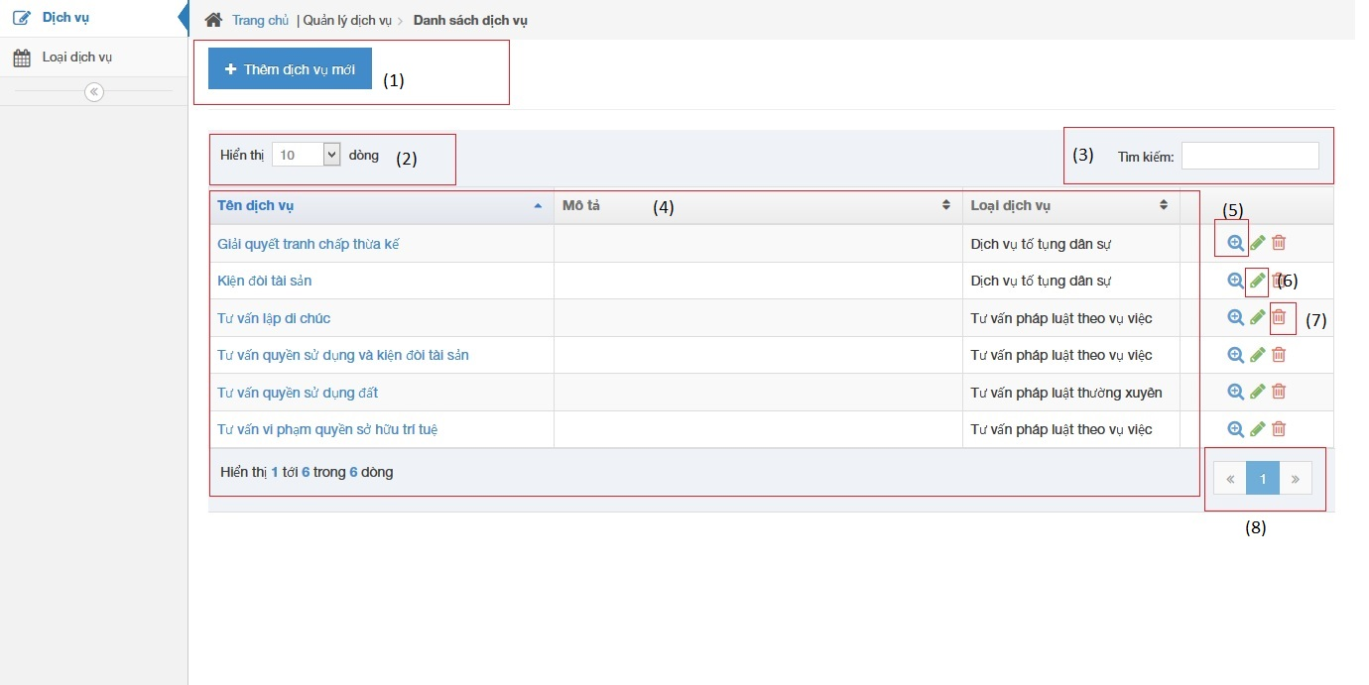

|  |  |  |  |  |
| --- | --- | --- | --- | --- |
| No | Object/ControlName | Type | Required | Description |
| 1 | Thêm dịch vụ mới | Button | Yes | Show Add new service pop-up |
| 2 | Number of rows | Combo-box | Yes | Choose number of rows in table |
| 3 | Search | Textbox | Yes | Search service |
| 4 | Services table | Table | Yes | List service |
| 5 | View service detail | Icon | Yes | Show service detail pop-up |
| 6 | Edit service | Icon | Yes | Delete service |
| 7 | Delete service | Icon | Yes | Show edit service pop-up |
| 8 | Paging | Button | Yes | Paging the service list |

#### Sequence diagram

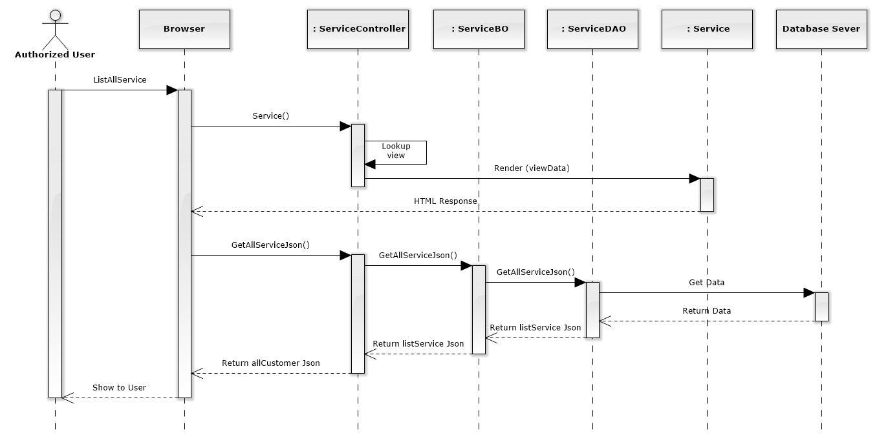

Figure 172: List Services Sequence Diagram

### Add new service

#### Screen design

#### 

|  |  |  |  |  |
| --- | --- | --- | --- | --- |
| No | Object/ControlName | Type | Required | Description |
| 1 | Tên dịch vụ | Textbox | Yes | Name Service |
| 2 | Loại dịch vụ | Combo-box | Yes | Service type |
| 3 | Mô tả | Textbox | Yes | Description |
| 4 | “Đóng” | Button | Yes | Click to close add new service pop-up |
| 5 | “Thêm mới” | Button | Yes | Click to add new service |

#### Sequence diagram

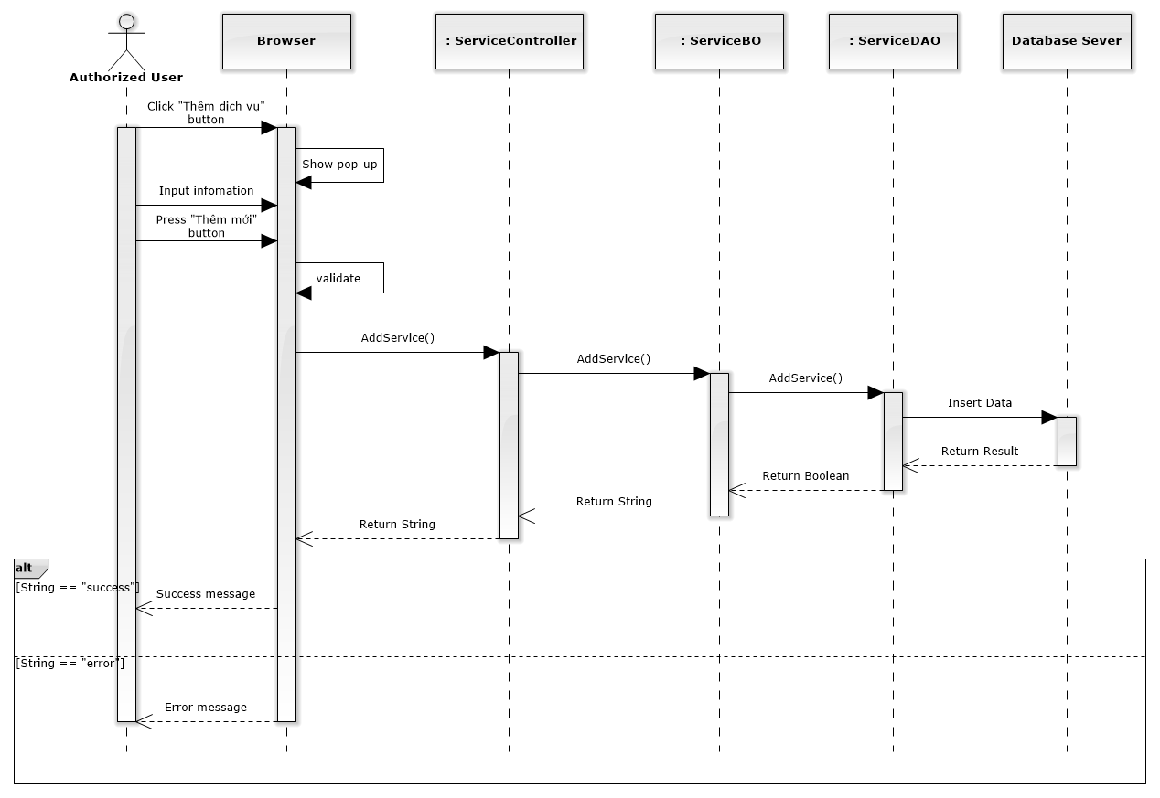

Figure 173: Add New Service Sequence Diagram

### Edit service

#### Screen design

#### 

|  |  |  |  |  |
| --- | --- | --- | --- | --- |
| No | Object/ControlName | Type | Required | Description |
| 1 | Tên dịch vụ | Textbox | Yes | Name Service |
| 2 | Loại dịch vụ | Combo-box | Yes | Service type |
| 3 | Mô tả | Textbox | Yes | Description |
| 4 | “Đóng” | Button | Yes | Click to close edit service pop-up |
| 5 | “Lưu chỉnh sửa” | Button | Yes | Click to save edit service |

#### Sequence diagram

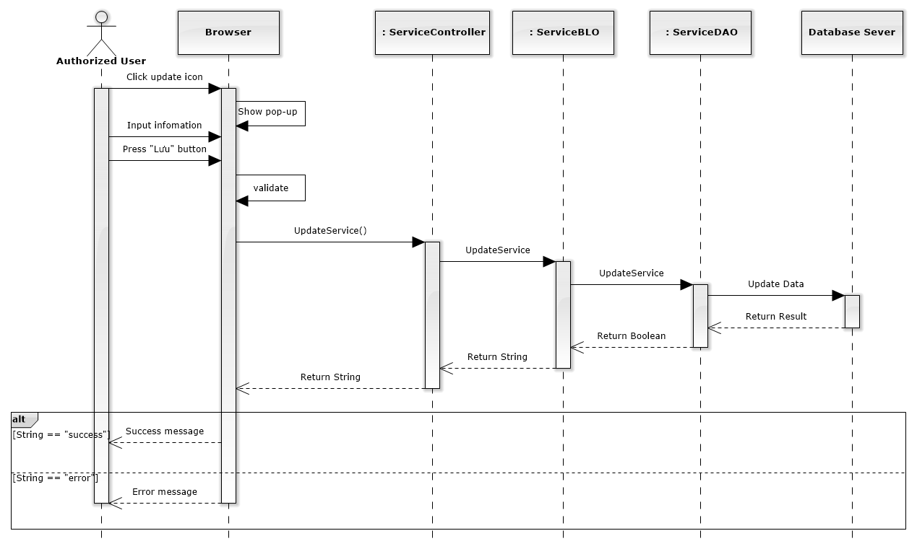

Figure 174: Edit Service Sequence Diagram

### Delete service

#### Screen design

#### 

|  |  |  |  |  |
| --- | --- | --- | --- | --- |
| No | Object/ControlName | Type | Required | Description |
| 1 | Bỏ qua | Button | Yes | Click to close delete service pop-up |
| 2 | Xác nhận | Button | Yes | Click to delete service pop-up |

#### Sequence diagram

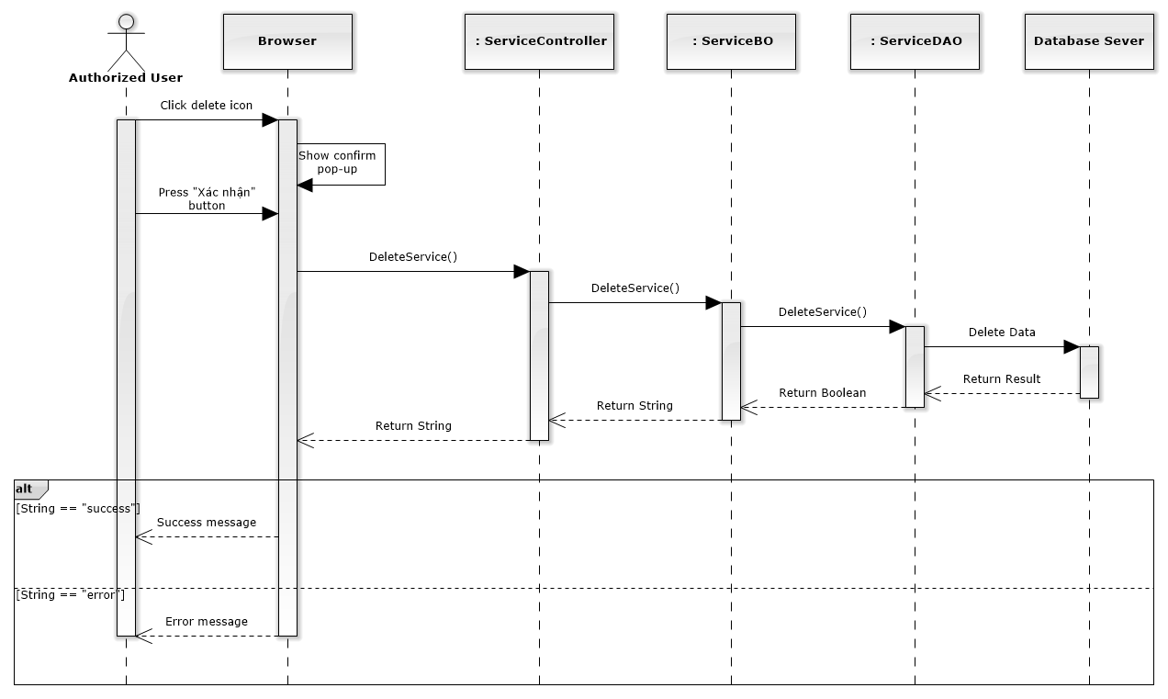

Figure 175: Delete Service Sequence Diagram

### List offices

#### Class diagram

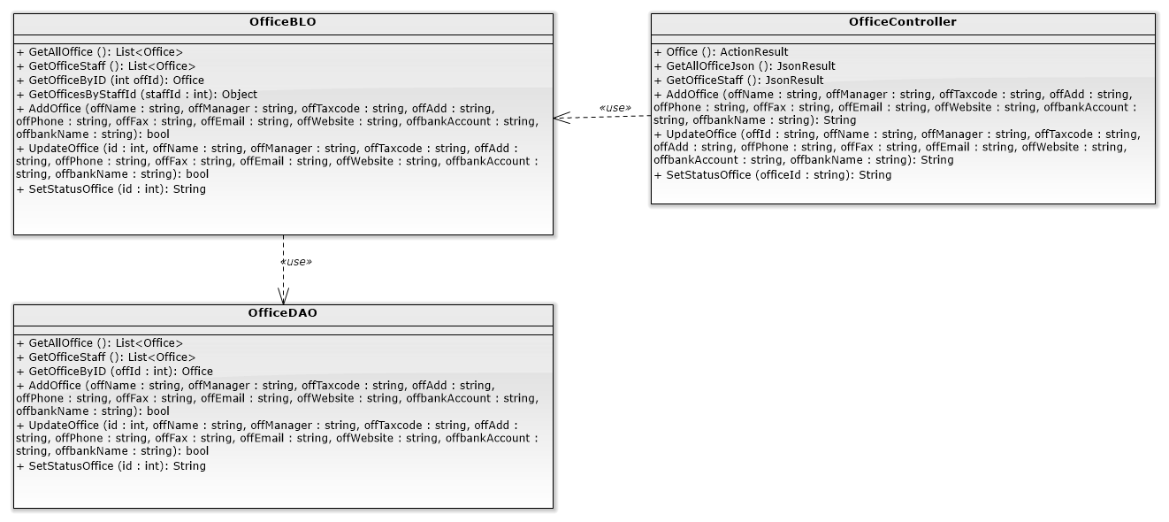

#### Screen design

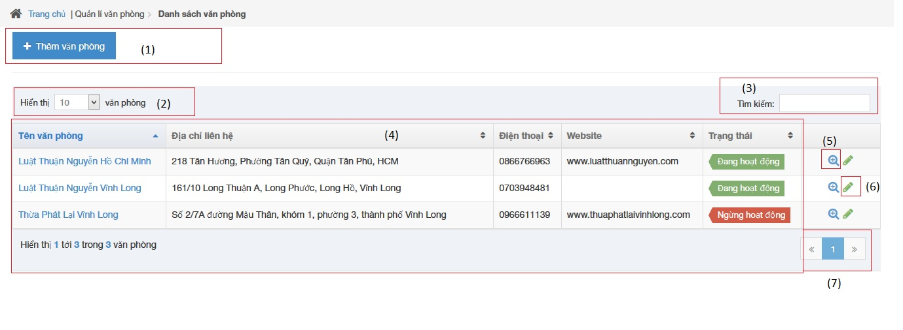

|  |  |  |  |  |
| --- | --- | --- | --- | --- |
| No | Object/ControlName | Type | Required | Description |
| 1 | Thêm văn phòng | Button | Yes | Click to show popup for add new office |
| 2 | Number of rows | Combo-box | Yes | Choose number of rows in table |
| 3 | Tìm kiếm | Textbox | Yes | Search office |
| 4 | List all office | Table | Yes | List all office |
| 5 | View | Button | Yes | Click to show popup detail of office |
| 6 | Edit | Button | Yes | Click to show popup edit detail of office information. |
| 7 | Paging | Button | Yes | Paging page |

#### Sequence diagram

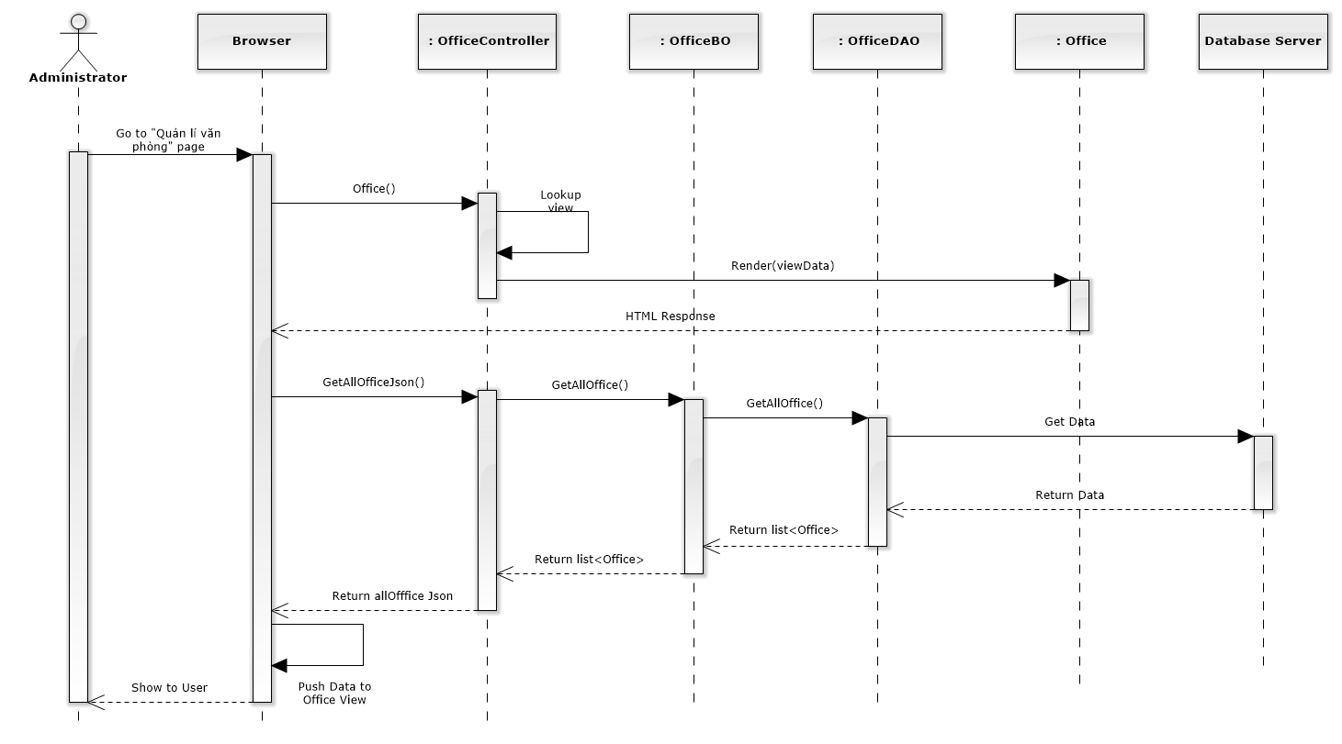

Figure 176: List Offices Sequence Diagram

### Add new office

#### Screen design

#### 

|  |  |  |  |  |
| --- | --- | --- | --- | --- |
| No | Object/ControlName | Type | Required | Description |
| 1 | Tên văn phòng | Textbox | Yes | Name of office |
| 2 | Người quản lí | Textbox | Yes | Nam’s manager of office |
| 3 | Số tài khoản | Textbox | Yes | Bank account number of office |
| 4 | Fax | Textbox | Yes | Fax of office |
| 5 | Email | Textbox | Yes | Email of office |
| 6 | Địa chỉ văn phòng | Textbox | Yes | Address of office |
| 7 | Điện thoại | Textbox | Yes | Phone number of office |
| 8 | Mã số thuế | Textbox | Yes | Tax number of office |
| 9 | Ngân hàng | Textbox | Yes | Name of bank of office |
| 10 | Website | Textbox | Yes | Website of office |
| 11 | “Làm trống” | Button | Yes | Clear field |
| 12 | “Thêm mới” | Button | Yes | Click to add new office |

#### Sequence diagram

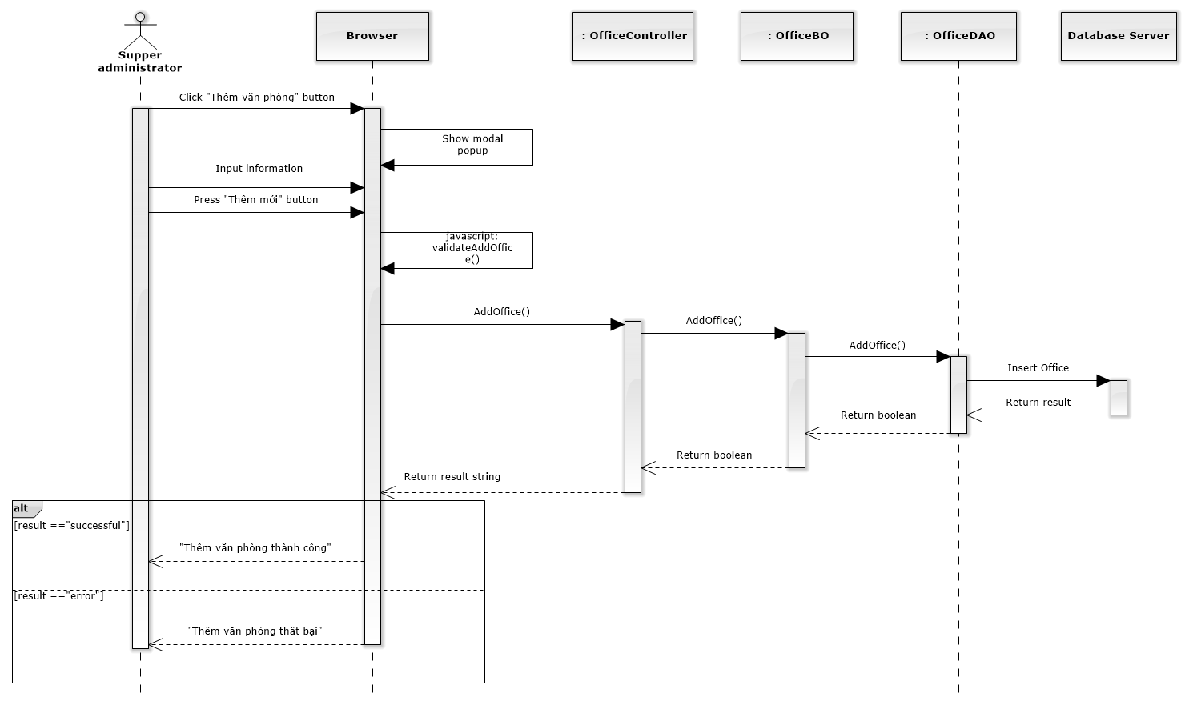

Figure 177: Add New Office Sequence Diagram

### Edit office

#### Screen design

#### 

|  |  |  |  |  |
| --- | --- | --- | --- | --- |
| No | Object/ControlName | Type | Required | Description |
| 1 | Tên văn phòng | Textbox | Yes | Name of office |
| 2 | Người quản lí | Textbox | Yes | Nam’s manager of office |
| 3 | Số tài khoản | Textbox | Yes | Bank account number of office |
| 4 | Fax | Textbox | Yes | Fax of office |
| 5 | Email | Textbox | Yes | Email of office |
| 6 | Địa chỉ văn phòng | Textbox | Yes | Address of office |
| 7 | Điện thoại | Textbox | Yes | Phone number of office |
| 8 | Mã số thuế | Textbox | Yes | Tax number of office |
| 9 | Ngân hàng | Textbox | Yes | Name of bank of office |
| 10 | Website | Textbox | Yes | Website of office |
| 11 | Ngừng hoạt động | Link | Yes | Status of office |
| 12 | “Đóng” | Button | Yes | Click to close edit office |
| 13 | “Lưu chỉnh sửa” | Button | Yes | Click to save edit office |

#### Sequence diagram

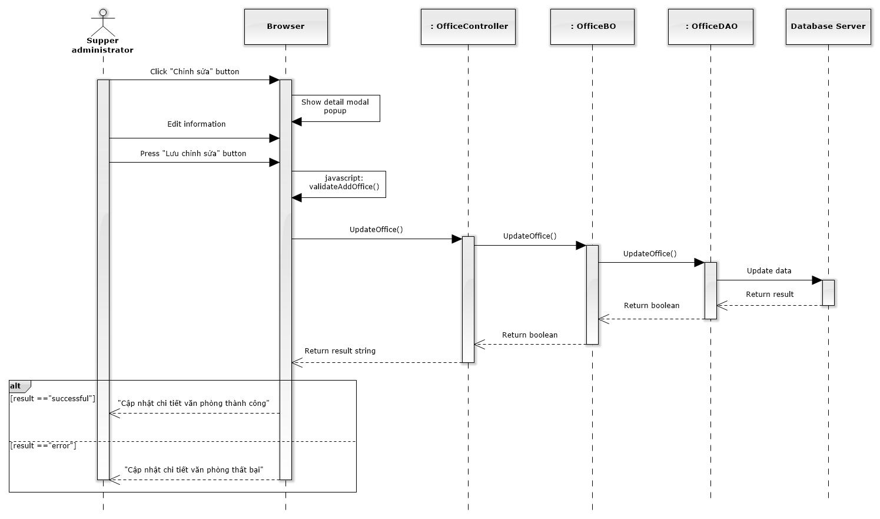

Figure 178: Edit Office Sequence Diagram

### Deactivate/ Activate office

#### Screen design

#### 

|  |  |  |  |  |
| --- | --- | --- | --- | --- |
| No | Object/ControlName | Type | Required | Description |
| 1 | “Bỏ qua” | Button | Yes | Click to close Deactive office |
| 2 | “Xác nhận” | Button | Yes | Click to Deactive office |
| 3 | Ngừng hoạt động | Link | Yes | Click to open confirm Deactive office |

#### Sequence diagram

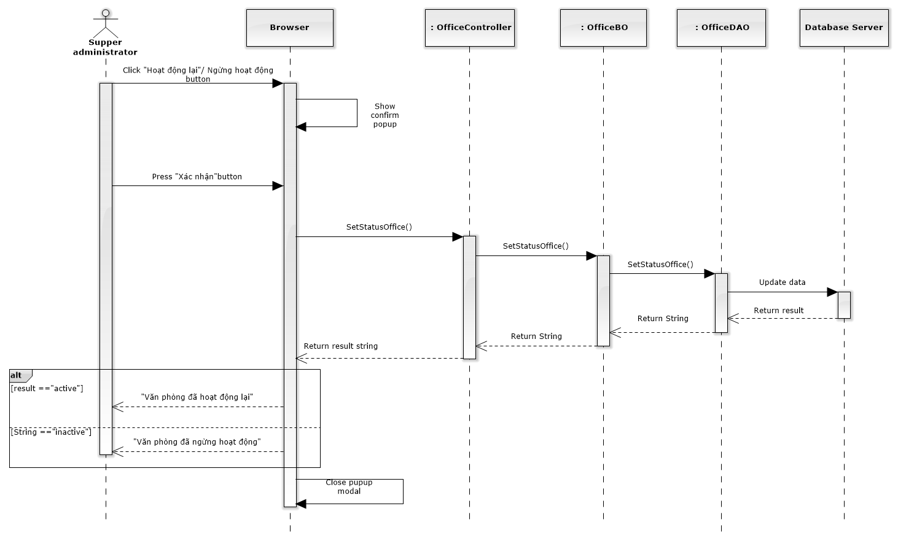

Figure 179: Deactivate / Activate Office Sequence Diagram

### Office statistic

#### Class diagram

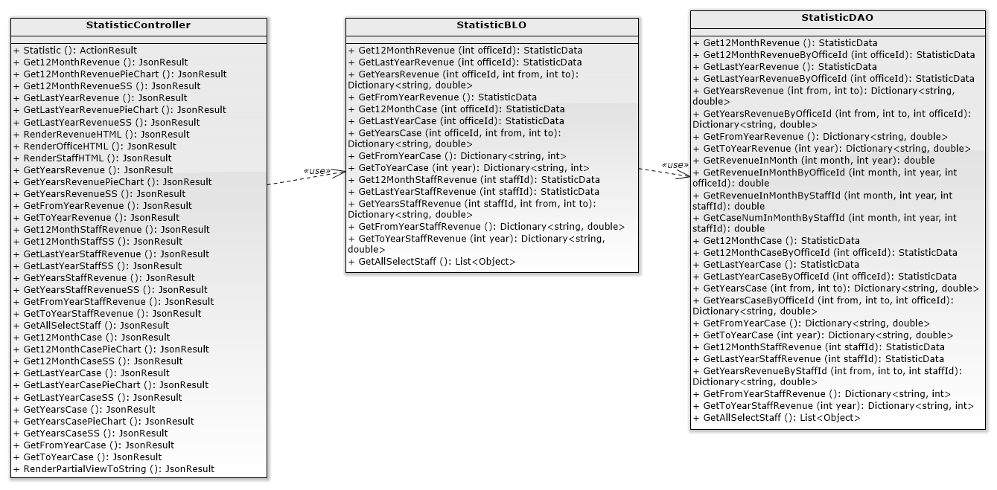

#### Screen design

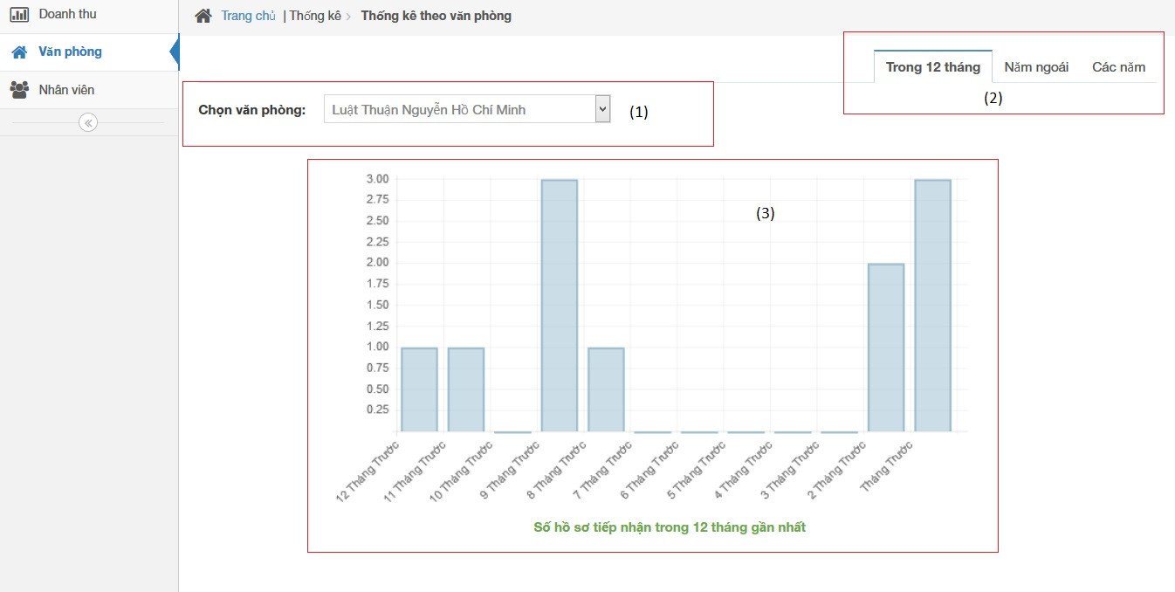

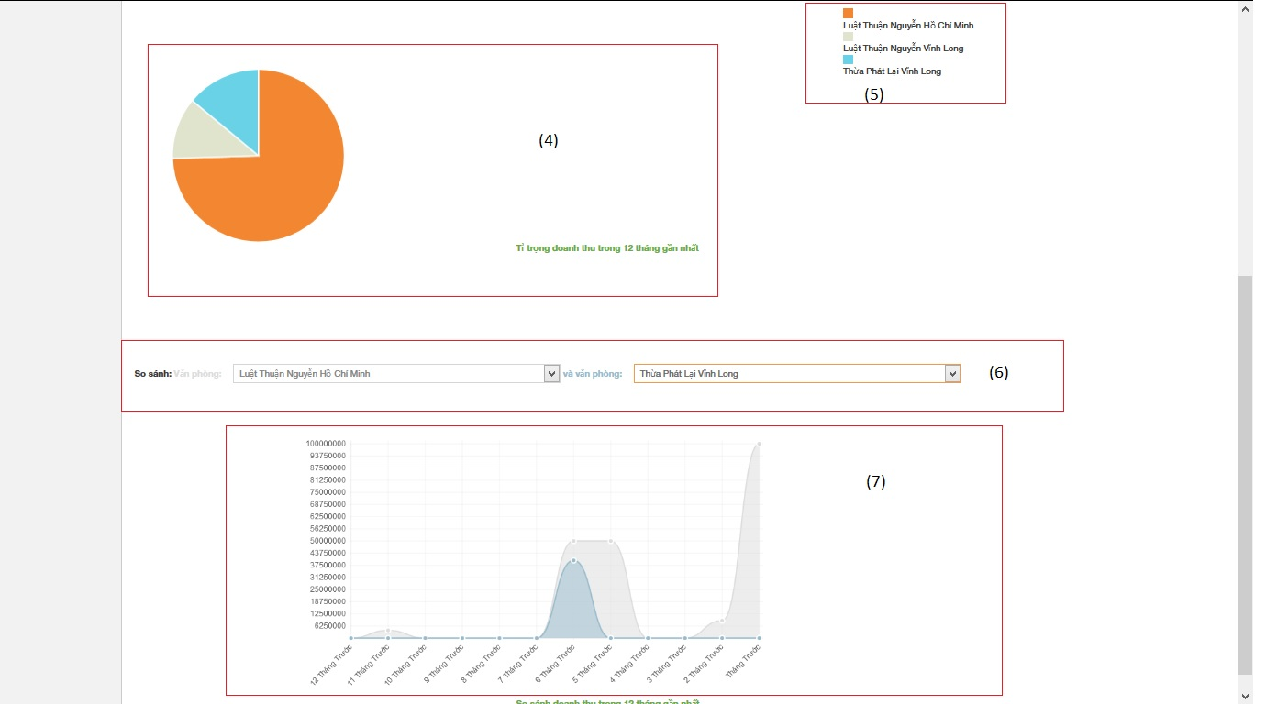

|  |  |  |  |  |
| --- | --- | --- | --- | --- |
| No | Object/ControlName | Type | Required | Description |
| 1 | Chọn văn phòng | Combo box | Yes | Click to choose name of office |
| 2 | Tab statistic | Link | Yes | Click to choose tab of statistic |
| 3 | Bar chart | Image | Yes | Image display of Bar chart |
| 4 | Pie chart | Image | Yes | Image display of Bar chart |
| 5 | Name office | Text | Yes | Name of office |
| 6 | Select name office | Combo box | Yes | Select name for comparison office |
| 7 | Comparison chart | Image | Yes | Image display of Bar chart |

#### Sequence diagram

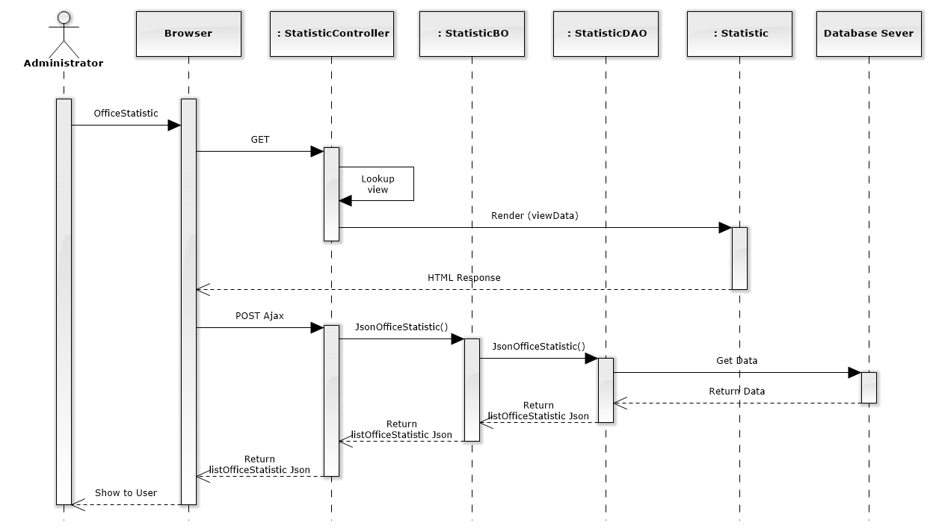

Figure 209: Office Statistic Sequence Diagram

### Staff statistic

#### Screen design

#### 

#### 

|  |  |  |  |  |
| --- | --- | --- | --- | --- |
| No | Object/ControlName | Type | Required | Description |
| 1 | Chọn luật sư | Combo box | Yes | Click to choose name of staff |
| 2 | Tab statistic | Link | Yes | Click to choose tab of statistic |
| 3 | Bar chart | Image | Yes | Image display of Bar chart |
| 4 | Select name staff | Combo box | Yes | Select name for comparison staff |
| 5 | Comparison chart | Image | Yes | Image display of Bar chart |

#### Sequence diagram

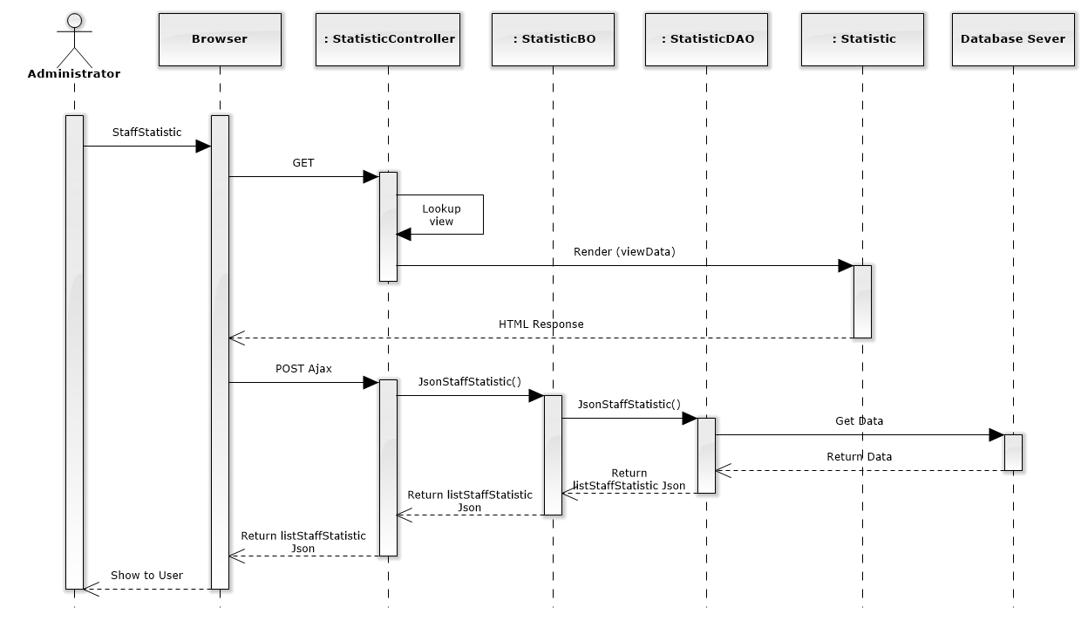

Figure 210: Staff Statistic Sequence Diagram

### Revenue statistic

#### Screen design

#### 

#### 

|  |  |  |  |  |
| --- | --- | --- | --- | --- |
| No | Object/ControlName | Type | Required | Description |
| 1 | Chọn văn phòng | Combo box | Yes | Click to choose name of office |
| 2 | Tab statistic | Link | Yes | Click to choose tab of statistic |
| 3 | Bar chart | Image | Yes | Image display of Bar chart |
| 4 | Pie chart | Image | Yes | Image display of Bar chart |
| 5 | Name office | Text | Yes | Name of office |
| 6 | Select name office | Combo box | Yes | Select name for comparison office |
| 7 | Comparison chart | Image | Yes | Image display of Bar chart |

#### Sequence diagram

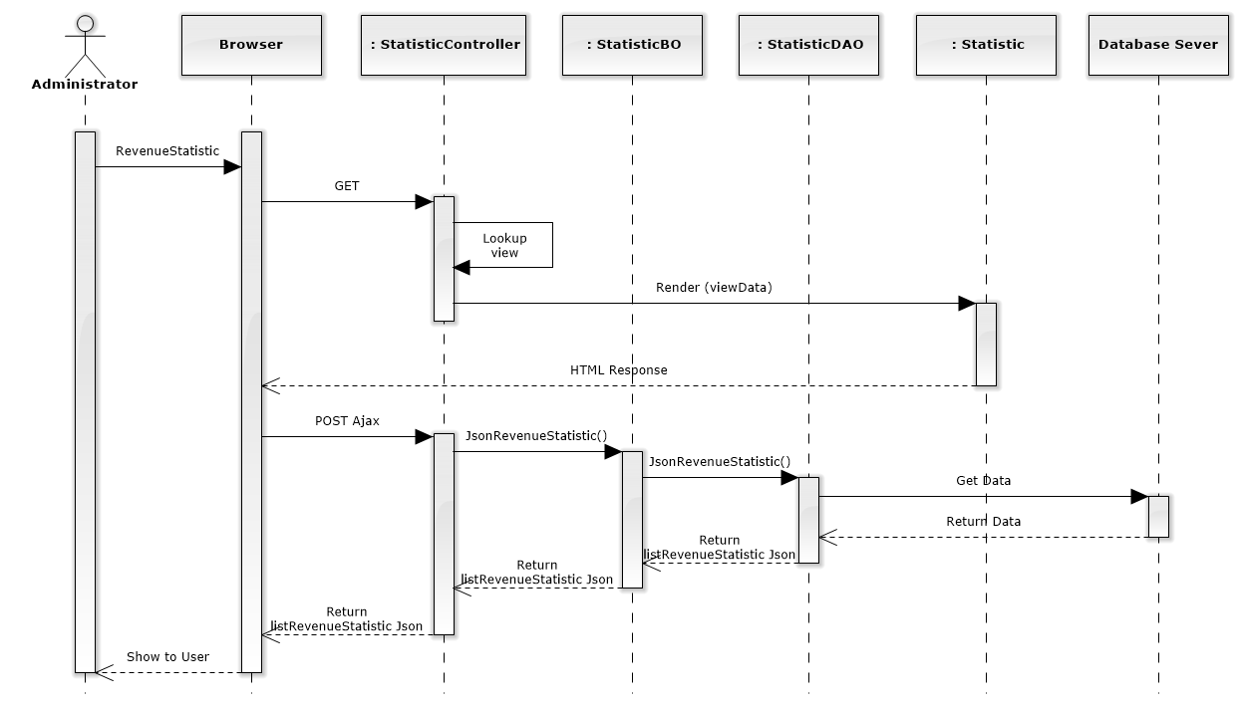

Figure 211: Revenue Statistic Sequence Diagram

1. Database Design

### Relational Database Diagram

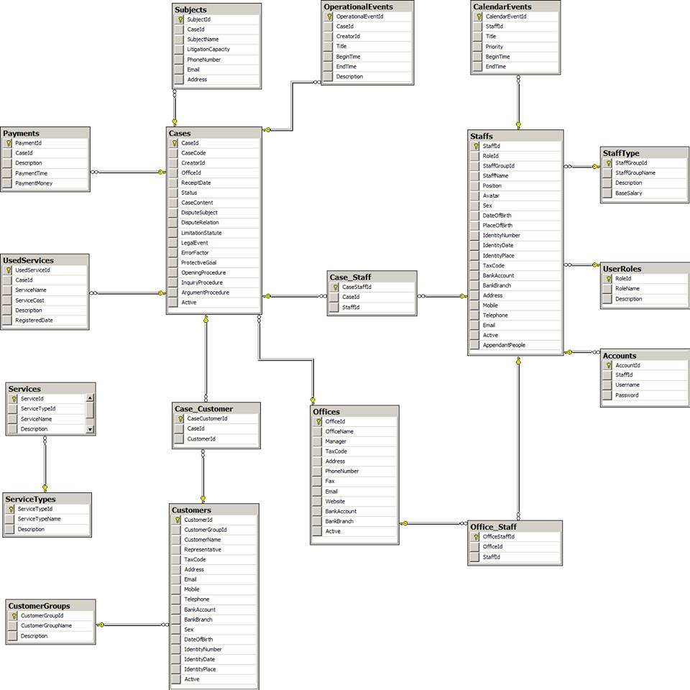

Figure 235: Relational Database Diagram

### Table Dictionary

#### Cases Table

|  |  |  |  |  |
| --- | --- | --- | --- | --- |
| Field Name | Type | Null | P/F Key | Thuật ngữ tiếng Việt |
| CaseId | int |  | PK |  |
| CaseCode | nvarchar(50) |  |  | Mã hồ sơ |
| CreatorId | int |  | FK |  |
| OfficeId | int |  | FK |  |
| ReceiptDate | date |  |  | Ngày thụ lý |
| Status | nvarchar(50) |  |  | Trạng thái hồ sơ |
| CaseContent | nvarchar(MAX) |  |  | Nội dung |
| DisputeSubject | nvarchar(MAX) | x |  | Đối tượng tranh chấp |
| DisputeRelation | nvarchar(MAX) | x |  | Quan hệ tranh chấp |
| LimitationStatute | nvarchar(MAX) | x |  | Thời hiệu |
| LegalEvent | nvarchar(MAX) | x |  | Sự kiện pháp lý |
| ErrorFactor | nvarchar(MAX) | x |  | Yếu tố lỗi |
| ProtectiveGoal | nvarchar(MAX) | x |  | Mục tiêu bảo vệ |
| OpeningProcedure | nvarchar(MAX) | x |  | Phần thủ tục bắt đầu |
| InquiryProcedure | nvarchar(MAX) | x |  | Phần thủ tục xét hỏi |
| ArgumentProcedure | nvarchar(MAX) | x |  | Phần tranh luận |
| Active | bit |  |  |  |

#### OperationEvents Table

|  |  |  |  |  |
| --- | --- | --- | --- | --- |
| Field Name | Type | Null | P/F Key | Thuật ngữ tiếng Việt |
| OperationalEventId | int |  | PK |  |
| CaseId | int |  | FK |  |
| CreatorId | int |  | FK |  |
| Title | nvarchar(100) |  |  | Tiêu đề |
| BeginTime | datetime |  |  | Thời gian bắt đầu |
| EndTime | datetime |  |  | Thời gian kết thúc |
| Description | nvarchar(MAX) | x |  | Mô tả nội dung |

#### Subjects Table

|  |  |  |  |  |
| --- | --- | --- | --- | --- |
| Field Name | Type | Null | P/F Key | Thuật ngữ tiếng Việt |
| SubjectId | int |  | PK |  |
| CaseId | int |  | FK |  |
| SubjectName | nvarchar(50) |  |  | Tên chủ thể |
| LitigationCapacity | nvarchar(50) |  |  | Tư cách tố tụng |
| PhoneNumber | nvarchar(20) | x |  | Số điện thoại |
| Email | nvarchar(50) | x |  | Hòm thư |
| Address | nvarchar(100) | x |  | Địa chỉ |

#### UsedServices Table

|  |  |  |  |  |
| --- | --- | --- | --- | --- |
| Field Name | Type | Null | P/F Key | Thuật ngữ tiếng Việt |
| UsedServiceId | int |  | PK |  |
| CaseId | int |  | FK |  |
| ServiceName | nvarchar(50) |  |  | Tên dịch vụ sử dụng |
| ServiceCost | int |  |  | Chi phí của dịch vụ |
| RegisteredDate | date |  |  | Ngày đăng ký dịch vụ |
| Description | nvarchar(MAX) |  |  | Mô tả chi tiết |

#### Payments Table

|  |  |  |  |  |
| --- | --- | --- | --- | --- |
| Field Name | Type | Null | P/F Key | Thuật ngữ tiếng Việt |
| PaymentId | int |  | PK |  |
| CaseId | int |  | FK |  |
| Description | nvarchar(MAX) |  |  | Mô tả chi tiết |
| PaymentTime | datetime |  |  | Thời gian thanh toán |
| PaymentMoney | int |  |  | Số tiền thanh toán |

#### Staffs Table

|  |  |  |  |  |
| --- | --- | --- | --- | --- |
| Field Name | Type | Null | P/F Key | Thuật ngữ tiếng Việt |
| StaffId | int |  | PK |  |
| StaffGroupId | int |  | FK |  |
| StaffName | nvarchar(50) |  |  | Tên nhân viên |
| Position | nvarchar(50) | x |  | Chức vụ |
| Avatar | nvarchar(100) | x |  | Đường dẫn ảnh đại diện |
| Sex | nvarchar(30) | x |  | Giới tính |
| DateOfBirth | date |  |  | Ngày sinh |
| PlaceOfBirth | nvarchar(100) | x |  | Nơi sinh |
| IdentityNumber | nvarchar(12) |  |  | Số CMND |
| IdentityDate | date |  |  | Ngày cấp |
| IdentityPlace | nvarchar(50) |  |  | Nơi cấp |
| TaxCode | nvarchar(14) | x |  | Mã số thuế |
| BankAccount | nvarchar(20) | x |  | Số TK ngân hàng |
| BankBranch | nvarchar(50) | x |  | Chi nhánh ngân hàng |
| Address | nvarchar(100) |  |  | Địa chỉ |
| Mobile | nvarchar(20) |  |  | Số di động |
| Telephone | nvarchar(20) | x |  | Số máy bàn |
| Email | nvarchar(50) |  |  | Hòm thư |
| Active  AppendantPeople | bit  int | x |  | Người phụ thuộc |

#### StaffType Table

|  |  |  |  |  |
| --- | --- | --- | --- | --- |
| Field Name | Type | Null | P/F Key | Thuật ngữ tiếng Việt |
| StaffGroupId | int |  | PK |  |
| StaffGroupName | nvarchar(50) |  |  | Tên nhóm nhân viên |
| Description  BaseSalary | nvarchar(MAX)  float | x  x |  | Mô tả chi tiết  Lương cơ bản |

#### UserRoles Table

|  |  |  |  |  |
| --- | --- | --- | --- | --- |
| Field Name | Type | Null | P/F Key | Thuật ngữ tiếng Việt |
| RoleId | int |  | PK |  |
| RoleName | nvarchar(50) |  |  | Tên vai trò |
| Description | nvarchar(MAX) | x |  | Mô tả chi tiết |

#### Accounts Table

|  |  |  |  |  |
| --- | --- | --- | --- | --- |
| Field Name | Type | Null | P/F Key | Thuật ngữ tiếng Việt |
| AccountId | int |  | PK |  |
| StaffId | int |  | FK |  |
| RoleId | int |  | FK |  |
| Username | nvarchar(50) |  |  | Tên đăng nhập |
| Password | nvarchar(50) |  |  | Mật khẩu |

#### CalendarEvents Table

|  |  |  |  |  |
| --- | --- | --- | --- | --- |
| Field Name | Type | Null | P/F Key | Thuật ngữ tiếng Việt |
| CalendarEventId | int |  | PK |  |
| StaffId | int |  | FK |  |
| Title | nvarchar(100) |  |  | Tiêu đề |
| Priority | nvarchar(50) |  |  | Mức độ ưu tiên |
| BeginTime | datetime |  |  | Thời gian bắt đầu |
| EndTime | datetime |  |  | Thời gian kết thúc |

#### Customers Table

|  |  |  |  |  |
| --- | --- | --- | --- | --- |
| Field Name | Type | Null | P/F Key | Thuật ngữ tiếng Việt |
| CustomerId | int |  | PK |  |
| CustomerGroupId | int |  | FK |  |
| CustomerName | nvarchar(50) |  |  | Tên khách hàng |
| Representative | nvarchar(50) | x |  | Người đại diện |
| TaxCode | nvarchar(14) | x |  | Mã số thuế |
| Address | nvarchar(100) |  |  | Địa chỉ |
| Email | nvarchar(50) |  |  | Hòm thư |
| Mobile | nvarchar(20) |  |  | Số di động |
| Telephone | nvarchar(20) | x |  | Số máy bàn |
| BankAccount | nvarchar(20) | x |  | Số TK ngân hàng |
| BankBranch | nvarchar(50) | x |  | Chi nhánh ngân hàng |
| Sex | nvarchar(20) | x |  | Giới tính |
| DateOfBirth | date | x |  | Ngày sinh |
| IdentityNumber | nvarchar(12) | x |  | Số CMND |
| IdentityDate | date | x |  | Ngày cấp |
| IdentityPlace | nvarchar(50) | x |  | Nơi cấp |
| Active | bit |  |  |  |

#### CustomerGroups Table

|  |  |  |  |  |
| --- | --- | --- | --- | --- |
| Field Name | Type | Null | P/F Key | Thuật ngữ tiếng Việt |
| CustomerGroupId | int |  | PK |  |
| CustomerGroupName | nvarchar(50) |  |  | Tên nhóm khách hàng |
| Description | nvarchar(MAX) | x |  | Mô tả chi tiết |

#### Offices Table

|  |  |  |  |  |
| --- | --- | --- | --- | --- |
| Field Name | Type | Null | P/F Key | Thuật ngữ tiếng Việt |
| OfficeId | int |  | PK |  |
| OfficeName | nvarchar(100) |  |  | Tên văn phòng |
| Manager | nvarchar(50) |  |  | Quản lý |
| TaxCode | nvarchar(14) | x |  | Mã số thuế |
| Address | nvarchar(100) |  |  | Địa chỉ |
| PhoneNumber | nvarchar(20) |  |  | Số điện thoại |
| Fax | nvarchar(20) | x |  | Số Fax |
| Email | nvarchar(50) |  |  | Hòm thư |
| Website | nvarchar(50) | x |  | Địa chỉ web |
| BankAccount | nvarchar(20) | x |  | Số TK ngân hàng |
| BankBranch | nvarchar(50) | x |  | Chi nhánh ngân hàng |
| Active | bit |  |  |  |

#### Services Table

|  |  |  |  |  |
| --- | --- | --- | --- | --- |
| Field Name | Type | Null | P/F Key | Thuật ngữ tiếng Việt |
| ServiceId | int |  | PK |  |
| ServiceTypeId | int |  | FK |  |
| ServiceName | nvarchar(50) |  |  | Tên dịch vụ |
| Description | nvarchar(MAX) | x |  | Mô tả chi tiết |

#### ServiceTypes Table

|  |  |  |  |  |
| --- | --- | --- | --- | --- |
| Field Name | Type | Null | P/F Key | Thuật ngữ tiếng Việt |
| ServiceTypeId | int |  | PK |  |
| ServiceTypeName | nvarchar(50) |  |  | Tên loại dịch vụ |
| Description | nvarchar(MAX) | x |  | Mô tả chi tiết |